


Stewardship Report
2024/25



This report meets the requirements of the Financial Reporting Council (FRC’s) – UK Stewardship Code 2020 and Cumbria Local Government Pension Scheme is listed as a signatory to the UK Stewardship Code (‘the Code’)

CUMBRIA LOCAL GOVERNMENT PENSION SCHEME

STEWARDSHIP REPORT 2024/25

Principle | Description of Contents | Page

Purpose and Governance
1 | Purpose, strategy and culture. | 3
2 | Governance, resources and incentives. | 8
3 | Conflicts of interest. | 21
4 | Promoting well-functioning markets. | 25
5 | Review and assurance. | 29

Investment Approach
6 | Client and beneficiary needs. | 34
7 | Stewardship, investment and ESG integration. | 38
8 | Monitoring managers and service providers. | 44

Engagement
9 | Engagement. | 47
10 | Collaboration. | 57
11 | Escalation. | 60

Exercising Rights and Responsibilities
12 | Exercise rights and responsibilities. | 64
Appendix A: Glossary |  | 72

PRINCIPLE 1: Purpose, investment beliefs, strategy & culture enable stewardship that creates long-term value for employers & beneficiaries leading to sustainable benefits for the economy, the environment and society.

  - Background & Purpose:

    - The Local Government Pension Scheme (LGPS) is a statutory scheme, established by an Act of Parliament and governed by the Public Services Pensions Act 2013 (PSPA 2013). It is a contributory defined benefit scheme to provide pensions and other related benefits for all eligible employees of local government and other participating employers.

    - Whilst the regulations are set on a national basis, individual Funds are managed by designated administering authorities at a local level. The LGPS, unlike private pension schemes, does not have Trustees but elected Members that perform similar duties to Trustees. The Pension Committee is a committee constituted under Section 101 of the Local Government Act 1972, the principal aim is to carry out the functions of Westmorland and Furness Council as the Administering Authority for the Cumbria Local Government Pension Scheme (“the Cumbria Pension Fund” or “the Fund”) in accordance with the requirements of the Local Government Pension Scheme and any other relevant legislation.

    - The LGPS, and therefore the Fund, is a multi-employer scheme which is open to new membership. The purpose of the Fund is to pay Cumbria Pension Fund members’ pensions securely, affordably and sustainably over the short, medium and long term. The LGPS operates on a ‘funded’ basis, this means that contributions from employees and employers are paid into a fund which is invested, and from which pensions are paid. To do this, the Fund seeks to achieve sustainable, risk-adjusted performance of its investments over the long-term.

  - Culture, strategy and investment beliefs:

    - The Fund has a fiduciary duty to its employers and members, and it recognises the important role of being a responsible asset owner – including the clear articulation of investment beliefs and strategy, values and organisational culture - in delivering this. This is articulated in the Fund’s Investment Strategy Statement (ISS) which sets out its core behaviours (1.2.3 below) and its investment beliefs (1.2.4 below).

    - The Fund considers that having a clearly defined culture, strategy and investment beliefs assists it to choose managers and other service providers whose approach is most closely aligned to that of the Fund.

    - The Fund’s behaviours and culture revolve around the following core principles:
      - Communicate in a clear and constructive way;
      - Act with honesty and respect for others;
      - Demonstrate a positive flexible attitude;
      - Take responsibility for our actions;
      - Obtain and maintain the appropriate knowledge and skills to understand the investments and risks undertaken within the Fund; and
      - Act in the best interest of all employers and members of the Fund.

    - The Fund’s investment beliefs are detailed in Annex A of the ISS and are reviewed annually to ensure they remain relevant and appropriate. These beliefs were subject to a detailed review and updated by the Pensions Committee in September 2023.

    - These beliefs recognise that the Cumbria Pension Fund is committed to being a responsible asset owner and believes that responsible investment can help to improve the long term value for investors. The Fund believes that this will help to achieve its overall objective of managing a sustainable and solvent pension fund on behalf of its scheme members and employers.

    - The Fund’s behaviours and culture are also detailed within its Responsible Investment policy which was approved in March 2024 having been informed by broad engagement with key stakeholders. This is further detailed in Principle 6.

  - Activity and outcomes during 2024/25:

    - To ensure that the Fund’s investment beliefs, strategy and culture enable effective stewardship, the Fund has undertaken a number of actions during the year. The key actions undertaken, and outcomes thereof are covered within the relevant sections of this report as summarised below:

    - Reviewing and applying our policies: This is considered in detail in Principle 5 at 5.2.

    - Training: This is considered in detail in Principle 2 at 2.2.7 and 2.5.3.

    - Setting and reviewing the Fund’s business plan and budget: This is a core activity in the Fund’s calendar. The plan and budget are designed to translate the Fund’s beliefs, strategy and culture into clear, tangible actions and outcomes. They are considered and set by Committee annually in March, and the Committee receives and considers a formal mid-year review of progress and forecast outturn each December.

    - The Local Pension Board (LPB) also has oversight of the Fund’s business plan and budget which ensures it remains appropriate to meet the underlying interests of clients & beneficiaries.

    - The Business Plan and Budget for 2024/25 were agreed at the meeting of the Committee on 14 March 2024 and progress against the plan was reviewed at the 10 December 2024 meeting of the Committee. The provisional budget outturn – including a summary of business plan achievements - was reported to the Committee at its meeting on 17 June 2025.

    - Key elements of the business plan for the year which relate to investment beliefs, strategy and culture and which enable effective stewardship included:

INVESTMENT MANAGEMENT – Investment Strategy

Planned activity

Complete the Fund’s Investment Strategy Review, to consider the key outcomes of the 2022 actuarial valuation and the revised Responsible Investment Strategy.

Seek suitable investment options to implement the Investment Strategy approved by Pensions Committee.

Liaise with the Fund’s chosen pooling company - Border to Coast Pensions Partnership Ltd (BCPP) - to ensure that suitable opportunities exist within the pool for the Fund to transition to its amended Investment Strategy.

Monitor progress in moving towards the final target Investment Strategy and keep its ongoing suitability under review.

Consider how the Fund can develop its reporting on climate metrics to demonstrate its progress against being a Responsible Investor.

Actions taken

During 2024/25 the Fund completed its Investment Strategy Review, which had included a review of its Investment Beliefs and its Responsible Investment Policy. The revised Investment Strategy was approved by the Pensions Committee in June 2024.

New investment commitments to BCPP private markets funds were agreed by Pensions Committee in March 2024 including commitment to a UK Opportunities Fund and Climate Opportunities Fund. Additionally during the year, the Fund transferred its English direct property holdings to BCPP’s UK Real estate fund.

The Fund is considering its approach for ongoing monitoring and reporting of climate metrics.

Outcomes

The Target Investment Strategy is included within the ISS available on the Fund’s website.

OVERSIGHT AND GOVERNANCE – Training

Please see 2.5.3 in Principle 2.

OVERSIGHT AND GOVERNANCE – Response to financial, regulatory and structural change

Planned activity

Review of governance arrangements in response to financial, regulatory and structural changes.

Actions taken

Members and officers attend a range of training courses and webinar broadcasts to assist in keeping abreast of changes to financial, regulatory and structural changes. Pensions Committee and the Local Pension Board are briefed on any developments at each meeting.

The Pension Regulator’s new General Code came into effect on 27 March 2024 and the Fund assessed its compliance with this and produced an action plan to address the limited number of areas where further development of governance arrangements are required.

Implementation of the plan is ongoing and is being monitored by the Local Pension Board.

The Fund has continued its membership of the Local Authority Pension Fund Forum (LAPFF), a collaborative shareholder engagement group for Local Authority Pension Funds. Further details of this is set out under Principle 9 at 9.4.

Outcomes

Key outcomes include:
- The approval by the FRC of the Fund’s Stewardship Report for 2023/24 in February 2025;
- The annual report has been completed in line with updated guidance and was published by the 1 December deadline; and
- Progress on evolving the Fund’s approach to RI. The Fund recognises that this is an iterative process and work is ongoing.

OVERSIGHT AND GOVERNANCE – Policies & strategies

Planned activity

Reviewing and updating the Fund’s risks, policies and strategies

Actions taken & Outcome

These are summarised in Principle 5 of this report at: 5.2 and 5.5.

SUMMARY OUTCOME: The Fund considers that in terms of the work undertaken in the year it has been effective in serving the best interests of clients and beneficiaries.

  - Future Developments:

    - Climate Reporting - As noted in section 2.5.3, officers and Members of the Fund have attended a number of workshops and events on Responsible Investment (RI). Climate and investment reporting has been a key focus of much of these sessions and the Fund is looking to build on the knowledge gained from them to assist it in developing its own reporting (see 5.6).

PRINCIPLE 2: Signatories’ governance, resources and incentives that support stewardship.

  - Governance structure:

    - The Fund believes that effective internal governance arrangements are fundamental to effective stewardship. The Administering Authority, as a Local Authority, must adhere to applicable regulations such as the Local Government Act 2000 and LGPS specific regulations such as the Local Government Pension Scheme Regulations 2013. As such, the governance structures and processes for the Fund are designed to comply with relevant regulatory requirements whilst also seeking to deliver effective oversight and accountability and, ultimately, effective stewardship.

    - Details of the governance arrangements for the Fund are set out in the Constitution of Westmorland and Furness Council. In summary the core governance arrangements of the Fund consist of the elements shown in the diagram overleaf.

    - Details of how these are resourced, including the workforce structure and information about qualifications, experience and training are set out in section 2.2 below. To support the core governance arrangements summarised in the diagram, the Fund also accesses a number of specialist service providers. Further details of these are set out in sections 2.2.12, 2.2.13 and 2.3 below.

Westmorland & Furness Council (W&F): is the Administering Authority for the management of the Cumbria Local Government Pension Scheme. As such it has the ultimate responsibility for stewardship. Under section 101 of the Local Government Act 1972 W&F has delegated a number of its functions as the Administering Authority to the Cumbria Pensions Committee (‘the Committee’) and to the S151 Officer (Director of Finance).
Section 151 Officer (Director of Finance) (see also 2.2.5 below) – The Section 151 Officer has the powers necessary to discharge the Council's functions in relation to pensions, including taking decisions which are not specified in the Constitution or in law as having to be taken by elected members or another officer, in relation to pensions. As such, the Section 151 Officer has a significant role in the stewardship of the Fund and its assets,
Westmorland & Furness Council (W&F)

Investment Sub Group (ISG) (2.2.2) - has an advisory role. It assists the Pensions Committee monitoring investment opportunities, investment manager performance and the progress of implementing the Fund’s Investment Strategy.

Cumbria Pensions Forum - the purpose of the Cumbria Pensions Forum is to seek the views of stakeholders within the Cumbria Pension Fund, provide information on performance across the management disciplines of the Fund and discuss items of common interest in relation to pensions.
Advisors (2.2.4) and Officers (2.2.5) - Advice is given by W&F’s S151 Officer, the Council’s Pensions Finance Team and by independent advisors. The current advisors are appointed for their complementary knowledge and experience of investments, actuarial matters and wider pensions issues. Advice is also provided by the Fund Actuary, specialist legal advisors to the Fund, and by other experts where appropriate, e.g. for investment management services, specialist tax advice, etc. (also detailed at 2.2.12)
Cumbria Local Pension Board (2.2.3) - the Board’s role is to assist the Administering Authority to fulfil its functions in relation to all aspects of governance, administration and stewardship of the Pension Fund. The Board is constituted under the Public Service Pension Act 2013 and the Local Government Pension Scheme (Amendment) (Governance) Regulations 2014 and has no remit as a decision-making body. Where the Board is concerned that due consideration has not been given to matters of non-compliance the Board may submit a report for consideration by W&F’s Audit and Assurance Committee.
Cumbria Pensions Committee (see also 2.2.1 below) - The LGPS, unlike private pension schemes, does not have trustees but elected Members perform similar duties to Trustees. The core functions of the Administering Authority are delegated to the Committee, as such the Committee has core accountability for the stewardship of the Fund. Key activities relating to these are summarised at 2.5.2 below.
KEY: Administering Authority Decision-maker Advisory body Oversight body
Consultative body Reports to Supported by Officers  Supported by Independent Advisors
S151 Officer (Director of Finance)
Pensions Committee
Investment Sub Group
LGPS Local Pensions Board
Pensions Forum

  - Resourcing of stewardship activities:

    - Cumbria Pensions Committee: In 2024/25 the membership of the Pensions Committee comprised 8 Members of Westmorland and Furness Council: 3 co-opted Members of Cumberland Council, and 2 employee representatives (one appointed by GMB and one appointed by UNISON). All members of the Committee including co-opted members are entitled to vote. Equal weight is given to each member’s vote with the Chair having the casting vote should the need arise.

    - The Investment Sub Group (ISG): In 2024/25 the membership of the ISG consisted of 4 elected members of the Pensions Committee (nominated by the Pensions Committee, taking into account knowledge, understanding and capacity), the two Independent Advisors to the Pensions Committee, and the Chief Finance Officer (Section 151 Officer) (or deputy in their absence).

    - Cumbria Local Pension Board (the LPB): In 2024/25 the membership of the LPB comprised 3 scheme employer representatives (allocated: 1 to Westmorland and Furness Council, 1 to Cumberland Council, and 1 for all other employers within the Cumbria Fund), 3 scheme member representatives (selected to ensure all membership groups within the Fund are covered), and 1 independent member (non-voting) appointed as Chair.

    - Independent Advisors: As noted above, the Independent Advisors are appointed for their knowledge of investments and of pension funds.

Independent Advisor
Mrs C Scott  (to July 2024) | Giffordgate Limited
Mr Alistair Sutherland  (Interim - from July 2024) | Horizon Investment Advisory Ltd
Mr Jonathan Hunt
(from September 2024)
Mr Louis-Paul Hill  (September 2024 - March 2025) | LPH Consulting

    - S151 Officer and LGPS Pensions Officers: the experience, qualifications and structure of the team of officers supporting the Council in carrying out its functions as Administering Authority for the Fund is included below.

Experience | Relevant formal qualifications
  < 1 year experience | 0%
  1-5 years’ experience | 0%
  6-10 years’ experience | 9%
  11-15 years’ experience | 18%
  > 15 years’ experience | 73%
  Formal qualification | 64%
  No formal qualification | 36%

S151 Officer and LGPS Pensions Officers team structure (during 2024/25):

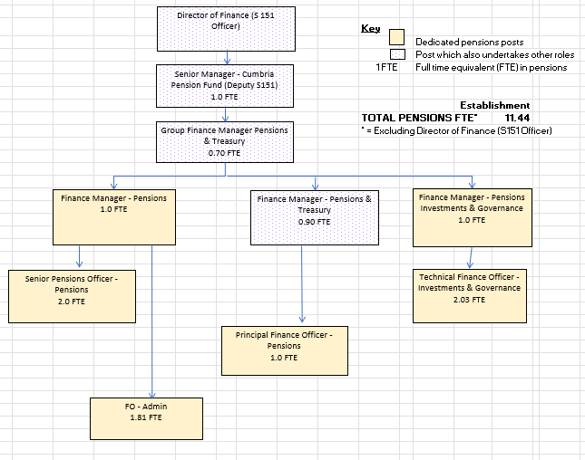

    - Diversity Neither the Fund nor the Council currently formally reports on workforce diversity although the Council does report on the Gender Pay Gap. The latest report on this can be found at: Pay Gap Report 2024. The council is committed to promoting equality and diversity - as an employer, in the services it provides, in partnerships, and in the decisions it makes. The council’s approach to Equality and Diversity is set out online at: Equality and Diversity

    - Training: A core principle of the Fund and a major factor in its governance and stewardship arrangements is ensuring Committee Members and Officers have appropriate skills and knowledge. Training helps build and maintain a strong culture of good governance, assists in the identification and implementation of investment beliefs, strategy, and ultimately supports and enables effective stewardship. In recognition of this, the Fund has a training policy and plan in place.
    - The plan and policy are designed to ensure that Officers and Members meet the knowledge and skills obligations and expectations set out in regulation and as articulated by relevant bodies such as the Pensions Regulator (tPR) and CIPFA. In line with good practice the policy is designed to be dynamic and aligned to the work programme, national policy and regulatory changes. The plan and policy are considered and set by Committee annually in March, and the Committee receives a formal mid-year review of progress against the plan each December.

    - The training policy was reviewed to ensure continued compliance with tPR’s expectations for Member and officer training and its requirements in relation to acquiring and maintaining an appropriate degree of knowledge and understanding.

    - In December 2023 a training needs assessment questionnaire was sent to all Member and substitutes Members of the Pensions Committee and the Local Pension Board. The helped inform the development of the 2024/25 training plan for the Committee and Board. Monitoring of progress against the plan is undertaken by officers informally throughout the year and any significant matters reported on an ad hoc basis to the Committee as appropriate. Details of training undertaken during the year are set out below at 2.5.3.

    - Systems, processes, research and analysis: The Fund does not undertake any investments directly - it engages external managers to invest on its behalf. As such it draws on specialist systems, processes, research, analysis and reporting from its external advisors and investment managers to support its stewardship activities. To ensure that these external systems, processes etc. are operating effectively, the Fund undertakes a review of internal control reports from its key managers as part of its year-end accounting processes. Work undertaken as part of the 2024/25 year-end has identified that controls and processes are operating in line with expectations.

    - Other Advisors: The Fund’s principle professional advisors are summarised in the table below along with details of the key services they provided to the Fund during the year:

Specialism | Company | Key Services provided during the year
Actuary | Mercer Ltd | Work undertaken includes: IAS 19 valuations, triennial valuation, advice on bulk transfers & admissions, input into the review of the Investment Strategy and provision of funding updates.
Pensions Administration (a delegated function from Westmorland and Furness Council to Lancashire County Council) | Local Pensions Partnership Administration (LPPA) | Work undertaken by LPPA includes the provision of core administration services such as the maintenance of member records, undertaking relevant pensions calculations and the provision of a Helpdesk and email facility for enquiries for both members and employers.
Auditor | Grant Thornton UK LLP | Annual statutory audit of the Fund’s Financial Statements.
Bank | National Westminster Bank PLC | Banking services.
Custodian & Performance Monitoring | Northern Trust Company | Record keeping/custody of the Pension Fund’s pooled funds, passive funds and cash; settlement of subscriptions, redemptions, capital calls, distributions; investment accounting quarterly and annually to LGPS/IFRS regulations; ONS reporting; and performance reporting.
Legal - LGPS | Eversheds Sutherland | Provision of specialist advice on aspects of the laws and regulations of England relevant to LGPS funds and pools, Administering Authorities, and scheme employers (in respect of their participation in the LGPS) e.g. investment work, benefit administration, employer bodies & governance work.
Legal – General | Westmorland and Furness Council Legal Services | Provision of general advice on laws and regulations relevant to the Council and the Fund.
Legal – Class Actions | Institutional Protection Services (IPS) / Labaton Sucharow (class actions) | To file claims in opt out and opt in shareholder/non-shareholder anti-trust class actions, group investor actions and Direct actions on behalf of the Fund.
Performance Monitoring | PIRC - Local Authority Pension Performance Analytics | Peer Group Analysis: participation in the Local Authority Universe and customised analysis.  IFRS Sensitivity Analysis: provision of sensitivity template to calculate potential volatility published in the Fund’s financial statements.

    - Investment Managers: As previously noted the Fund does not undertake any investments directly, it engages external managers to invest on its behalf. The below table sets out the managers currently engaged by the Fund to manage its investment assets and the proportion of assets invested with each manager. This includes BCPP which, as detailed below at 2.3, is the Fund’s chosen approach to meet the Government’s requirement to pool investment assets in the LGPS in England and Wales.

Manager | Core Asset Class | % of Fund at 31/03/25
Abrdn Group (previously Aberdeen Standard Investments) | Direct property | 0.1
Apollo Global Management | Multi Asset Credit Fund | 1.6
Aviva | Long lease property Fund | 1.0
Barings | Private Loan Funds | 0.8
BlackRock Investment Management | Private Equity Fund | 0.1
BCPP – see section 2.3 below | UK, Overseas & Global Equities, Multi Asset Credit, Property, Private Equity, Infrastructure, Private Credit, Climate & UK Opportunities | 60.7
CQS | Multi Asset Credit Fund | 0.3
HealthCare Royalty Partners | Royalties Funds | 1.4
Hearthstone Investments | Residential Property Fund | 0.9
JP Morgan | Infrastructure Fund | 5.6
Legal & General Investment Management | Passive global equities, Index-linked gilts | 16.3
M&G | Property Fund | 0.9
Pantheon Ventures | Private Equity Funds | 1.7
Partners Group | Infrastructure & Private Market Credit Funds | 4.1
Patria (formerly SL Capital Partners) | Private Equity Fund | 1.3
Abrdn (formerly Aberdeen SL Capital) | Infrastructure Fund | 1.3
Unigestion | Private Equity Funds | 0.6
Various including Northern Trust | Cash | 1.3

  - Pool governance structure and resourcing:

    - As noted above, BCPP is the Fund’s chosen approach to meet Government’s requirement to pool investment assets in the LGPS in England and Wales. Throughout the year the Fund has continued with its strategy to transition assets to the pool, including the transition of its directly held property portfolio. In line with the Government’s ‘Fit for the Future’ requirements the Fund is working to bring all Fund assets to be either managed by or under management oversight of BCPP by 31 March 2026.

    - The Administering Authority is 1/11th equal shareholder in the company with the other equal shareholders being 10 other LGPS funds. The diagram below shows the governance structure in place to ensure that appropriate oversight of BCPP is carried out both from a shareholder and an investor perspective:
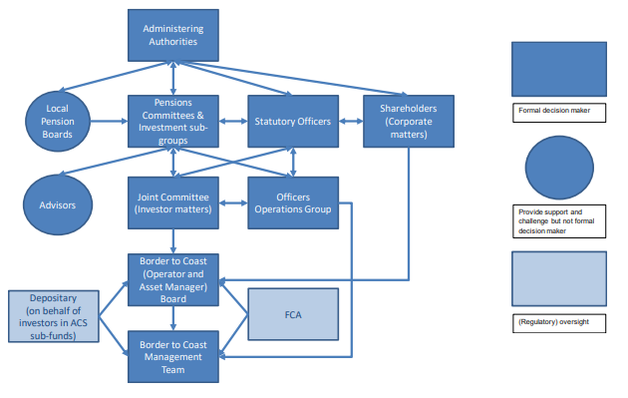
    - Further details of the Governance structure of the company can be found at:

BCPP Governance Charter 2025.

    - From the Fund’s perspective, the key mechanisms enabling it to have appropriate oversight of the company and hold it to account so as to ensure the effective stewardship of the Fund’s assets invested with BCPP include:

    - The Joint Committee: The Fund is represented on the Joint Committee (by the Chair of the Pensions Committee) where investment operations of the company are overseen.

    - In 2024/25 the Shareholder representative was the Director of Resources (Section 151 Officer) as Cumbria’s appointed representative to exercise the rights of the Administering Authority as shareholder of BCPP.

    - The Officer Operations Group and Statutory Officer group: Officers of the Fund attend both of these groups.

    - Non-Executive Directors: two shareholder-nominated (from partner funds) Non-Executive Directors have been appointed to the Board of the company who provide oversight of the Company.

    - In addition to this:
- The Fund monitors and reviews the investment performance of assets managed by BCPP, with Officers having ongoing dialogue with BCPP to discuss performance, and formally reporting on performance to the Committee and ISG on a quarterly basis.

- Through its contractual arrangements, the Fund requires BCPP to maintain regular dialogue with companies, other investors and professional advisors, which allows them to monitor the development of company’s businesses, corporate responsibility, financial performance, risk management (including those from environmental and social factors), capital structure, leadership team and corporate governance.

- The Fund in its capacity as a shareholder is able to influence the approach taken to incentives at the pool. The Fund supports BCPP’s approach to reward at the pool, to ensure long term incentives are aligned with our objectives. As a shareholder, the Fund is able to consider and approve the amount of, or any increase in, remuneration payable to any directors at the Company.

- The Fund also supports BCPP’s approach to engagement and voting rights to ensure the companies in which it invests are incentivised to deliver long term shareholder value. Further details of this can be found in the sections relating to Principles 9, 11 and 12.

  - Incentivising the integration of stewardship into investment decision-making:

    - The Fund seeks to incentivise the integration of stewardship into investment decision-making both internally (i.e. when setting its Investment Strategy) and externally when appointing specialist advisors and investment managers to assist its governance processes and deliver its investment requirements.

    - Internal incentives: The key mechanism for motivating the integration of stewardship into investment decision-making internally is the Fund’s governance structure. In particular, the setting of a clear Investment Strategy and investment beliefs and the ongoing monitoring of the performance of the Fund from the granular level (such as the performance of individual investments and the Environmental, Social and Governance (ESG) activities of the investment managers), through to the strategic level (such as the triennial actuarial valuation and undertaking in-depth Investment Strategy reviews). The key activities undertaken in relation to this during the year ended 31 March 2025 are described at 2.5.2 below.

    - External incentives: the first step in this process is selecting external advisors and asset managers which are already closely aligned with the values of the Fund. As such, consideration of a provider’s ‘fit’ with the Fund is a fundamental element of due diligence work prior to appointment. Furthermore, the Fund sets out clear requirements through its contracts / service level agreements. For example:
    - In accordance with the Competition and Markets Authority (CMA) Investment Consultancy and Fiduciary Management Market Investigation Order 2019, the Fund has set clear objectives for its Independent Advisors and where applicable any Investment Consultant. The objectives include setting a strategy based on the Fund’s goals/objectives and providing advice and assistance to the Pensions Committee on any other relevant issues that could impact the Pension Fund’s ability to meet its strategic objectives. The Fund continues to comply with the CMA’s requirements. (See Principle 8)

    - Once appointed, the Fund incentivises providers to align the work they do for the Fund with the Fund’s requirements and expectations in relation to stewardship through regular monitoring and evaluation of their performance and engaging with providers on an ongoing basis. For example:

    - As noted in section 2.3 above, the Fund in its capacity as a shareholder is able to influence the approach taken to incentives at the pool. The Fund supports BCPP’s approach to reward at the pool, to ensure long term incentives are aligned with the Fund’s objectives. As a shareholder, the Fund is able to consider and approve the amount of, or any increase in, remuneration payable to any directors at the company. The Fund also supports BCPP’s approach to engagement and voting rights to ensure the companies in which the Fund is invested are incentivised to deliver long term shareholder value (further details on this are set out in the Principles 9, 11 and 12 ).

  - Effectiveness of governance structures and processes in supporting stewardship

    - Targets set within the 2024/25 Business Plan were achieved during the year with key tasks either completed, or ongoing work that is on track for completion and these have been delivered within the approved budget. The effectiveness of the Fund’s governance structures and processes was also demonstrated by their resilience during the COVID-19 pandemic.

    - Core governance processes relating to the stewardship of its investment assets undertaken by the Fund during the year ended 31 March 2025:

Activity | Further information
Production and monitoring of progress of the business plan for the year | For further details please see 1.3.4 in Principle 1.
Undertake a full Investment Strategy Review, to consider the key outcomes of the 2022 actuarial valuation and their implications for the Fund going forwards. | For further details please see 1.3.4 in Principle 1.
Review of BCPP’s Responsible Investment Policy & Corporate Voting Guidelines | Further details of this work can be found in Principles 9 and 12 in this report.
Formal annual review of Fund policies | This is considered in detail in Principle 5 and included a new RI Policy.
Overseeing performance of the Fund’s Investment Managers and BCPP | This includes voting and engagement activities and is undertaken throughout the year with formal reporting to the Committee and ISG taking place on a quarterly basis.
Production of the Pension Fund Accounts and Annual report | The Accounts and Annual Report for the year ended 31 March 2024 were published in accordance with statutory timescales. The unaudited Accounts for the year ended 31 March 2025 have been published on the Funds website at: https://www.cumbriapensionfund.org/media/mzmjng3i/cumbria-lgps-2024-25-unaudited-accounts.pdf.  The final Accounts and Annual Report documents are due to be published later in the year.
Identifying and implementing appropriate investments to meet the requirements of the Fund’s Investment Strategy | During the year the Fund identified and implemented a number of investments to meet the requirements of its Investment Strategy. These included:  - New investment commitments to BCPP private markets funds including commitment to a UK Opportunities Fund and Climate Opportunities Fund.  - Transferring its direct property holdings to BCPP’s UK Real estate fund in late 2024.
Undertaking its role as a Shareholder of BCPP Limited | The Fund attended all Shareholder meetings (formal and informal) of the company. The Fund also attended all BCPP Joint Committee meetings. In addition, Officers attended other key governance meetings with BCPP including the Officer Operations Group, the Statutory Officers group and Responsible Investment workshops.
Training on relevant matters | For further details please see 2.2.7 above and 2.5.3 below.
Contributing nationally to the development of policy and regulation relating to the LGPS and wider public sector pensions policy. | During the year the Fund responded to the following consultations:  - Response to Pensions Review 2024 Phase 1: Call for Evidence – September 2024

    - Training: During the year ended 31 March 2025 the Fund agreed its training plan for the period at its meeting in March 2024. In line with good practice the Fund undertakes a mid-year review of the training policy and this was considered by Committee in December 2024. In summary:

Planned activity

Review, measure and deliver training to Members and officers as outlined in the annual Training Plan.

Actions taken

The Plan incorporated six key themes, three of which are directly relevant to the stewardship of the Fund’s investment assets. These, along with the activity undertaken in relation to them and the outcomes of that activity are summarised below:

Themes:

(1) Impact of the Fund’s Investment Strategy review on its asset allocation and how transition to the revised strategy will be managed including the need for appropriate cashflows and how investment and other risks may affect the value of assets and liabilities within the Fund.

(2) Stewardship Reporting including ESG factors including the role of BCPP and the Fund’s membership of LAPFF.

(3) Reporting on climate metrics and progress of delivering the Fund’s responsible investment strategy.

Activities:

Training included:
- In-house training sessions on:
  - Governance structure of the Cumbria Fund.
  - Climate metrics and reporting.
  - Pensions Dashboards.
  - Cyber Security.
- Officer & Member attendance at a number of training events including the LAPFF Annual Conference & LGA Annual LGPS Governance Conference.
- Attendance at regular RI meetings held with BCPP and Partner Funds.
- Webinar attendance - various e.g. LGPS Live, Net Zero in the LGPS.

Outcomes

To assess the effectiveness of the training (and to inform the next Training Plan) an annual Training Needs Assessment Questionnaire (TNA) is sent to all Members and Officers.

The TNA asks individuals to score the level of their knowledge in each key area and the outcome of this was fed into the Training plan for 2024/2025 with focus on those areas that scored the lowest.

Training has helped to build and maintain a strong culture of good governance, assisted in the identification and implementation of investment beliefs and strategy, and ultimately supported and enabled effective stewardship.

We recognise that RI is an evolving area and the Fund is keen to continue to increase its knowledge and skills in this area and this will continue to be reflected in future training plans.

SUMMARY OUTCOME: The Administering Authority reflected on the governance structure of Cumbria Pension Fund and amended terms of references for its key governance bodies as part of a wider review of the Council’s Constitution as a result of Local Government Reorganisation in 2023.

The Fund considers that its current governance structure and processes are appropriate in effective supporting good stewardship within the organisation.

  - Future Developments:

    - In May 2025 the results of the Governments ‘Fit for the Future’ Pension Review were published and confirmed that BCPP was recognised as being aligned with the Government’s vision for the future of LGPS pooling. In line with the requirements of the review the Fund will work with BCPP to bring all of the Fund’s assets either under pool management or under management oversight by March 2026.

    - Development of the BCPP’s next long-term RI strategy is ongoing and will include engagement with stakeholders across the organisation and Partner Funds.

    - In March 2024, tPR issued its General Code of Practice. Throughout 2024/25 the Fund assessed its compliance to this code and addressed any areas of non-compliance. The resultant action plan is reviewed regularly by the Cumbria LPB and progress reported to the Pensions Committee. Any additional requirements arising from the ‘Fit for the Future’ consultation will also be considered – see 5.6.2.

PRINCIPLE 3: Signatories manage conflicts of interest to put the best interests of clients and beneficiaries first.

  - Conflicts of interest policies

    - Conflicts of interest, including those relating to matters of investment stewardship, are managed according to the Fund’s Conflicts of Interest Policy. A new Conflicts of Interest Policy has been developed specifically for the Cumbria Pension Fund in line with the requirements and expectations detailed in tPR’s General Code of Practice. The policy can be viewed on the Funds website. It will be reviewed at least every three years.

    - This Conflicts of Interest Policy is supplementary to the Members Code of Conduct applicable to elected Members’ (of both the Pensions Committee and the LPB) respective Council and the Officer Code of Conduct for Westmorland & Furness Council (as the Administering Authority of Cumbria Pension Fund). The Codes are designed to promote and maintain high standards of conduct by Members and Officers of the Fund across all activities including the stewardship of the Fund’s assets. These are set out in the Council’s Constitution and can be found at:

      - Members’ Code of Conduct and guidance: Code of Conduct for Councillors
      - Officers’ Code of Conduct (including conflicts of interest): Officer Code of Conduct.

  - Identification and management of conflicts of interest

    - The Council delegates responsibility for the management of the Fund to the Director of Finance (S151 Officer) and the Pensions Committee. This includes the overall responsibility to ensure that systems, controls and procedures are adequate to identify, manage and monitor Conflicts of Interest.

    - In order to be able to identify and manage potential and actual conflicts of interest, Members, Advisors and Officers responsible for governing the Fund need to have a clear understanding of them. As such, training is a key tool to ensure Members and Officers are aware of and understand their responsibilities in relation to the Fund, including the identification and management of conflicts of interest. Further details on the Fund’s training policy and plan can be found in Principle 2 at 2.5.3.

    - Other key steps: the table below sets out the key steps employed by the Fund in the identification and management of actual and potential conflicts of interest relating to the stewardship of the Fund’s assets. Examples of how actual or potential conflicts have been addressed are set out at 3.3 below.

Identification | Management
Members of the Pensions Committee and LPB (‘Members’): All Members must declare any pecuniary or other registerable interests.  Members will be required to consider whether they have an interest in any matter on the agenda for a meeting and if so whether there is a need to disclose such an interest.  All formal meetings of the Committee and LPB have ‘disclosures of interest’ as a standing item on the agenda. At that point each Member formally considers conflicts of interest they may have in any item on the agenda or during discussions throughout the meeting and the outcome is declared in the public minutes. | The Fund maintains and monitors its own register of interests. This register is separate from the register of interests that elected members are required to complete for their respective Council as detailed within their Council’s Code of Conduct Policy.  Applicable persons will be required to submit an annual return confirming that their information contained in the register of interests remains correct and up to date. These are published on the Council’s website under each Member’s name and updated on a regular basis.  Full details of the process for the management of declarations of interests at meetings are set out in Part 4 section 1 Appendix B of the Constitution. An example of this is when a Member may have worked for or holds shares in a company that is a service provider to the Fund. Unless a dispensation has been granted, they must then leave the meeting room and may not participate in any discussion, vote on, or discharge any function related to the matter.
Advisors to the Fund: In accordance with the Council’s Constitution on appointment Independent Advisors are required to sign a declaration statement outlining any potential conflicts they may have.  Once appointed they must immediately report any changes of circumstance directly to the Chair of the Committee for their consideration and further action should this be necessary. | Post appointment: where a matter arises, which presents a potential or actual conflict of interest then the action taken to manage the conflict is considered by the Chair of the Committee in consultation with Fund Officers. Examples may include requiring the Advisor to not participate in the relevant discussion or to leave the meeting during the consideration of the matter.  During the year one of the Fund’s Advisors accepted a role with another pooling company which led to him resigning from his position.  Narrative about consideration of conflicts during the appointment process is detailed at 3.3.3 below.
Officers of the Fund (‘Officers’): Officers are required to make a formal declaration about any financial or non-financial interests which could bring about a potential or actual conflict of interest. Such declarations should be discussed with their line manager and submitted using the Council's online reporting tool. | Where a potential or actual conflict of interest is identified then the Officer may be removed from the relevant workstream.  Interactions of officers with Investment Managers is subject to the requirement for any gifts or hospitality to be declared and captured by the Fund.
Investment Managers: The Fund expects the asset managers it employs to have effective stewardship policies including conflicts of interest and voting & engagement, and that these are all publicly available on their respective websites.  These are considered as part of due diligence work undertaken prior to the appointment of a manager and manager policies are informally considered as part of the annual review process (see Principle 8). | The Fund collaborates with other Partner Funds and BCPP on an ongoing basis through Responsible Investment workshops and by feeding into the annual BCPP RI Policy review to facilitate the alignment of our approaches to stewardship where possible. See also 3.3.4 below.  The Fund is also working to improve how it engages with its other investment managers on their approach to stewardship. See RI questionnaire in Principle 7.  Work to date includes entering into an Investment Oversight Agreement with BCPP whereby the company provides Funds with an oversight service in relation to Legal & General’s (LGIM) management and stewardship of the passive funds including the provision of a comparison of LGIM and BCPP’s Responsible Investment Policy and Corporate Governance & Voting Guidelines (highlighting any differences between these policies).
Other service providers to the Fund: Consideration of potential and actual conflicts of interest is undertaken both prior to entering into a contract for service provision (i.e. at the procurement stage) and throughout the duration of the contract.  For example, the requirement to undertake a conflict check to confirm that no conflicts of interest were present in the tender process undertaken during 2024/25 for Legal Services to the fund. | Procurement: The Fund adheres to the Council’s Contract Procedure Rules (Constitution Part 3 Item 7) which set out a clear framework for the procurement of goods and services. The Rules state that Officers must comply with measures put in place by the Council to identify, prevent and remedy conflicts of interest which arise during procurement.  Contract management: Where a conflict is identified the steps taken will depend on the type of service provider. For example, if the provider for the Fund is engaged to provide advice for a different client which creates a conflict of interest or a significant risk of one, then the Fund would ensure that the provider adheres to their obligations in relation to both parties’ conflicts of interest policies.

  - Outcomes

    - All potential Conflicts of Interest have been managed effectively during 2024/25.

    - Independent Chair of Cumbria LPB: In June 2023 the Cumbria LPB appointed Patrick Mulligan as its first Independent Chair. Addressing potential conflicts of interest was included within the recruitment process, and upon appointment a Declaration of Interests form was completed. Declarations of Interest are a standing item on the Board’s agenda at each meeting.

    - Independent Advisors: New Investment Advisors were appointed to the Fund in July and September 2024. In accordance with the Fund’s Conflict of Interests Policy had to submit details of any potential conflicts of interest as part of their application which were considered as part of the selection process. They also had to complete a declaration of interest form upon appointment and notify the Fund immediately should a potential conflict arise. As noted in the table above one of the Advisors subsequently left the Fund as a result of taking on a conflicting role

    - Management of Stewardship Policies with BCPP: As owners of BCPP, all partner funds are involved in the development of the key stewardship policies within BCPP, namely the Responsible Investment Policy, Corporate Governance and Voting Guidelines and Climate Change Policy. There is a comprehensive and collaborative joint governance process to ensure that BCPP and each Pension Fund's own policies on Responsible Investment and Corporate Governance are aligned, to reduce the possibility of any conflicts in stewardship activity and ensure that RI activity undertaken by the Pool represents all partner funds beliefs. The annual governance process involves BCPP officers, partner fund officers, the Joint Committee, BCPP Board and the individual Fund Pension Committees (for further details see Principle 9 section 9.2).

    - Following the review undertaken by officers and the Chair and Vice Chair of Pensions Committee of the latest BCPP Responsible Investment Policies the Pensions Committee, at their 10 December 2024 meeting, noted the changes and that these amended policies continue to be aligned with the underlying principles of the Fund’s ISS.

SUMMARY OUTCOME: The Pension Fund considers that all potential conflicts of interest have been managed effectively during 2024/25 to deliver on the Fund’s fiduciary duty to put the best interests of clients and beneficiaries first.

  - Future Developments:

    - In 2024/25 a Conflicts of Interest policy was developed specifically for the Pension Fund. This policy will be reviewed at least every three years to ensure it remains fit for purpose and continues to fulfil the requirements and expectations detailed in tPR’s General Code of Practice.

PRINCIPLE 4: Signatories identify and respond to market-wide and systemic risks to promote a well-functioning financial system.

  - Identification of systemic & market-wide risks

    - The identification of and response to systemic and market-wide risks by the Fund is a key tool in its approach to addressing barriers to effective stewardship. The incorporation of ESG considerations, such as climate change, into investment decisions can help improve long-term value by minimising the risk of, for example, stranded assets and the impact of regulatory change.

    - The Fund's risk management process is in line with that recommended by the Chartered Institute of Public Finance and Accountancy (CIPFA). This is a continuous approach which systematically looks at risks surrounding the Fund's past, present and future activities, which includes systemic and market-wide risks in addition to Fund-specific risks. Risk identification is enhanced through liaison with investment managers, other administering authorities and regional and national groups, including the Scheme Advisory Board (SAB), CIPFA, and various investor collaborations and initiatives (see Principle 10).

    - Once identified, material risks are documented on the Fund's risk register, which is the primary control document for the subsequent analysis and classification, control and monitoring of those risks. The register is formally reviewed on a quarterly basis by the Committee and LPB.

    - The Fund’s approach to identifying and responding to systemic and market-wide risks is regularly reviewed, along with all aspects of governance. It is not deemed necessary to make any changes at this time as they are working effectively.

  - Response to systemic & market-wide risks (examples are summarised from Cumbria Pension Fund risk register 2024/25)

Risk | Response
Performance: Adverse market movements impact on the Fund’s long-term performance: e.g. Climate Change, increases in inflation, impact of armed conflicts etc. | - Adherence to the Fund’s Investment Strategy ensures that the assets of the Fund are invested in a diverse portfolio of investments, the impact on overall performance is therefore not as extreme as that experienced in any one asset class alone.  - Potential new investments are closely scrutinised by Officers and Fund Advisors to assess if the product meets the investment criteria of the Fund.  - The Fund believes that the best way to be a responsible investor and to influence policy change is not through divestment but through active engagement. The Fund considers that, by exerting pressure as an investor, it can bring more influence on companies than it could by boycotting specific sectors from its investment strategy.  - Inflation risk: Revisions to the Fund’s target Investment Strategy are carried out at least every three years and consider inflation risks and protection from different asset classes. An example being increasing the Fund’s investment in index-linked gilts. Furthermore mitigations of the risk of high short-term inflation are considered as part of the actuarial valuation.  - Climate Change: The Fund’s ISS sets out how the Fund incorporates ESG factors including climate change into the investment process. The Fund has responded to government consultations on Governance and Climate Risk Reporting ahead of the release of regulations relating to increased levels of disclosure on Climate Related risks and opportunities. The resulting increased level of disclosure will seek to ensure that the Fund understands and manages the financial risks and opportunities arising from climate change in order to protect and grow the Fund’s assets and cashflows.  - Geo-Political Events: This risk has the potential to increase global unrest and its potential impact on the investment markets and assumptions used by the actuary.  - The Fund will continue to monitor geo-political events and the impact these have on the Fund.
Regulatory Changes: There is a risk that the LGPS is mandated to invest in particular markets or risks that may otherwise impact onto the sovereignty of the Fund.  This may be caused by government policy or amendments to regulations. | - Officers of the Fund respond to government consultations where relevant to help influence policy.  - Where relevant, the Fund will support lobbying or lobby directly to ensure that its voice is heard in the development of national policy.  - Officers within the Fund ensure that they are aware of impending amendments to regulations and advise Pensions Committee and the LPB (and, where relevant, employers and scheme members) in a timely way as to any amendments and their impact to the Fund.

  - Working with other stakeholders and industry initiatives to promote a well-functioning financial system.

    - The Fund is a relatively small participant in the financial system and markets. As such, it is best placed to promote the continued improvement of the functioning of financial markets by working in partnership with other stakeholders and industry initiatives and by focussing on specific areas of risk.

BCPP
    - BCPP are committed to fundamental analysis and the prudent management of risks, engaging with investee companies to manage long-term risks that have the potential to impact investment returns including financial risks associated with climate change. They seek to understand how companies address climate risk, for example searching out those management teams that are at the forefront of understanding emerging threats. One of their US holdings, Berkshire Hathaway (reinsurance), limited its exposure to the California region leading to the company reporting estimated losses below peers following the wildfires; and another, Beazley (UK Lloyds insurance), stepped away from a US region (Florida) with significant exposure to hurricane risks thereby benefitting shareholders.

LAPFF
    - As a result of the ongoing conflicts across the globe, LAPFF has stepped up its engagement with both companies and other investors to understand better how to engage in a helpful way with companies operating in conflict affected and high-risk areas. The humanitarian and human rights conditions in these countries have a bearing on whether investee companies can create sustainable shareholder value. Given the importance of the issue and growing geo-political tensions LAPFF will be focusing considerable attention to the issue over the coming year.

    - LAPFF engage with policymakers and regulators as well as wider stakeholders on areas for reform to reduce the systemic risks facing LAPFF members. As part of this work, LAPFF continue to submit consultation responses focusing on policy areas important to its membership. LAPFF has become increasingly concerned about moves to lessen corporate governance standards in the UK and with its investor protections. Over the year, LAPPF has raised concerns with the London Stock Exchange Group about the influence of the Capital Markets Industry Taskforce.

    - In 2024 LAPFF joined Nature Action 100 (NA100) - a newly established global investor-led engagement initiative focussed on companies with significant impacts on nature. The objective of the initiative is to provide a framework through which investee companies can take urgent action to halt and reverse nature loss by assessing how nature-related risks and dependencies affect their business models.

SUMMARY OUTCOME: The Pension Fund’s approach to identifying and responding to systemic and market-wide risks is regularly reviewed, along with all aspects of governance. Whilst the current governance structure is considered to be effective in managing these risks, these will continue to be kept under regular review and updated as appropriate.

  - Future Developments:

    - The Fund will continue to work with BCPP and its partner funds to evolve the pool’s approach to addressing climate risk and implementing metrics and targets to move towards net zero emissions by 2050, or sooner.

    - As at March 2025 biodiversity loss is included in the Fund’s risk register as an emerging risk, however in future this risk will be incorporated within the “Climate Change” risk recognising its increasing significance as a global concern. The Fund will continue to engage on this issue through BCPP, LAPFF and associated investor collaborations.

PRINCIPLE 5: Signatories review their policies, assure their processes and assess the effectiveness of their activities.

  - Introduction

    - The Fund’s policies are the mechanism through which the Fund expresses and implements its investment beliefs, strategy and culture. They provide the framework for effective governance and stewardship – both of the Fund assets and of the Fund as a whole.

  - Policies

    - The current Fund Policies can be found on the website at: : Fund Policies. The Fund’s current policies and the purpose of each policy is summarised below:-

- Governance Policy Statement: sets out the roles and responsibilities and reports compliance against a set of best practice principles.

- Administration Strategy & Communications Policy: details the formal arrangements for pensions and benefits administration for the Fund, and the communications with members, employers and pensioners.

- Investment Strategy Statement (ISS): details how the Fund’s assets are invested, the fund managers and benchmarks, and the Fund’s compliance with the Financial Reporting Council’s UK Stewardship Code.

- Responsible Investment Policy: details how the Fund takes its shareholder / investor responsibility seriously and how it is involved from an engagement and influence perspective on the wider ESG agenda.

- Cash Investment Policy: the management of the pension fund cash, bank account and investment of surplus cash.

- Funding Strategy Statement (FSS): identifies how the Fund’s pension liabilities will be funded in the longer term and addresses solvency issues.

- Admissions & Termination Policy - details the policy on employer admissions and the methodology on cessation from the Fund.

- Discretions Policy - details the policy regarding the exercise of certain discretions to assist in the management of the Fund.

- Training Policy - sets out the policy concerning the training and development of members of all committees and officers responsible for management of the Fund.

- Policy & Procedure on Reporting breaches of the law - sets out the policy and procedures to be followed by persons involved with the Cumbria Pension Fund in relation to reporting breaches of the law.
- Internal Controls & Risk Management - sets out the policy approach within the Cumbria Pension Fund in relation to internal controls and risk management procedures that seek to protect the Fund from adverse risk.

- Conflicts of Interest - this policy sets out the process for identifying, assessing and managing conflicts of interest in the governance and management of the Fund.

Review Process

    - It is a regulatory requirement that Fund Policy documents are kept up to date. In addition to updates when required throughout the year, the Pensions Committee formally reviews them on an annual basis in March to ensure that the Fund’s policies remain fit for purpose (i.e. continue to reflect the Fund’s purpose and investment beliefs as well as meeting regulatory requirements). The review process seeks to ensure that the policy document complies with the requirement that it is fair, “balanced and understandable”. As such, it incorporates both fundamental changes, e.g. due to regulatory and/or legal changes, and more minor ‘housekeeping’ amendments for example to reflect the change to the financial year, to simplify language and to correct spelling, grammar and punctuation.

    - The first step of the review process is undertaken by Fund officers. The proposed changes to individual Policies are considered and approved at the next quarterly meeting of the Pensions Committee. In addition to this the Fund follows best practice and the Pensions Committee formally reviews the Fund’s policies at least annually.

    - The LPB, in their role in assisting the Administering Authority to ensure the efficient and effective governance of the Fund, review all Pensions Committee papers at their quarterly meetings. Whilst the LPB has no remit as a decision-making body, as the Fund’s Policies are a key governance tool, it is important that they give Fund Policies appropriate consideration. This is included in the formal Work Plan for the Board which is reviewed on a quarterly basis to ensure it captures any arising issues.

  - How the Fund gains assurance in relation to its stewardship and why

    - Cumbria Local Pension Board (LPB): As detailed in Principle 2, the LPB’s role is to assist the Administering Authority to fulfil its functions in relation to all aspects of governance, administration and stewardship of the Pension Fund. As such, it plays an integral part in providing assurance that the Fund is undertaking its governance and stewardship and appropriately.

    - External Audit: The annual Statement of Accounts for the Cumbria Pension Fund are subject to external audit by Grant Thornton. The External Auditor prepares an ‘Audit Findings Report’ (AFR). This work provides assurance that the financial statements of the Fund, which include details of investment performance and other core stewardship information present a ‘true and fair view’ of the financial transactions during the reporting year and of the amount and disposition of the Fund’s assets and liabilities at the end of that year.

    - Internal Audit: Internal controls are in place to ensure procedures and policies, which provide the framework for effective governance and stewardship, are followed. Internal Audit undertake an audit of the control environment, subject to a pre-agreed remit, to provide an assessment on the internal controls in operation and whether they are applied consistently.

    - Actuary: The Actuary prepares the valuation and sets the contribution rates to ensure Fund solvency and long-term efficiency with due regard to LGPS Regulations. The Actuary is instrumental in assisting the Fund in the production of its FSS and the Actuary’s valuation assumptions play a key role in the development of the ISS (both of which are key stewardship policy documents). Importantly, the valuation is a key tool in assessing the appropriateness - thereby providing assurance of the Fund’s Investment Strategy.

    - Independent Advisors: The Fund appoints external Independent Advisors, whose remit includes the provision of clear, concise and understandable investment and governance advice to the Pensions Committee and the ISG. The advisors also support members of the Committee, ISG and Officers in developing and reviewing the ISS relevant to the Fund’s current funding level and risk appetite. Their input into and challenge of the Fund’s approach to the stewardship of its assets is integral to providing assurance to the Pensions Committee that the Fund’s approach to stewardship is efficient and effective.

  - Reporting

    - The Fund employs a variety of methods to seek to ensure its stewardship reporting is fair, balanced and understandable. In addition to the sources of assurance set out above at 5.3 these include:
- Tailoring information to the target audience – for example reports to the ISG are designed to reflect the technical nature of the Group whilst this report and the Fund’s Annual Report are written for a more general audience and look to employ plain English throughout. See Principle 6 section 6.6 for more detail on Fund communications.
- Seeking external feedback – for example the Fund consulted on changes made to its Responsible Investment Policy in 2023/24 (see 5.5.1)
- Internal review – reports to the Committee, ISG, Board and publicly available reports are all subject to robust internal review by at least two officers other than the author.

  - Outcomes during 2024/25

    - Review of Policies: Examples of key changes to the Fund’s policies as a result of the previously described review process include:

Policy | Notes
ISS | Following the Fund’s Investment Strategy Review the amendments to the asset allocation model were integrated into a revised ISS. It was also updated to add reference to the standalone RI Policy approved by Committee in March 2024.
New Policy – a standalone Conflict of Interests Policy | A new Conflicts of Interest Policy has been developed specifically for the Cumbria Pension Fund in line with the requirements and expectations detailed in the Pension Regulator’s General Code of Practice. This Policy is supplementary to the Members Code of Conduct applicable to elected members’ respective Council and the Officer Code of Conduct for Westmorland & Furness Council (see Principle 3)
Governance policy Statement | Updated to align fully to the revised Constitution of the Administering Authority. In addition, sections have been added relating to the process for appointing to the Local Pension Board and Remuneration & Fee Policy. These have been added to comply with the Pension Regulator’s General Code of Practice.
Discretions Policy | Updated to reflect amendments to the LGPS Regulations to permit the payment of an exit credit to an employer terminating the Fund
Administration Strategy & Communications Policy | updated to note that where possible, the scheme employer should provide at least 30 days, and preferably 60 days notice of the retirement to LPPA, in order to ensure that the first pension payment is likely to be made within 30 days of retirement.
Revisions to Training Plan | To ensure continued compliance with tPR’s expectations in relation to acquiring and maintaining an appropriate degree of knowledge and understanding the training plan has been updated to incorporate areas highlighted following the completion of the annual training needs assessment questionnaires.

    - Assurance: Westmorland & Furness Council’s Internal Audit team have undertaken a review on internal controls associated with Pension Fund Investments. This audit provided “substantial assurance” that concluded that controls were operating effectively across the Fund.

    - Grant Thornton UK LPP, the Fund’s external auditor provided an unqualified opinion in relation to the Fund’s 2023/24 Annual Statement of Accounts (audited in 2023/24). The audit of the 2024/25 Annual Statement of Accounts is in progress as at the date of submission of this report.

    - No material areas of concern were raised in relation to the Fund as a result of the previously described assurance work undertaken both internally and externally during 2024/25.

SUMMARY OUTCOME: The Pension Fund regularly reviews its policies ensuring these remain relevant and effective.

The effectiveness of the Fund’s policies and processes have been subject to internal and external assurance which has resulted in no material concerns for the Fund.

  - Future Developments:

    - In developing the Fund’s RI Policy the Pensions Committee agreed to develop a specific Climate Change Policy; this work has been paused pending the implementation of the Pensions Review.

    - Part of the Government’s ‘Fit for the Future’ consultation published in May proposed new governance requirements which included some of the areas that were first proposed in 2021 as recommendations from the Scheme Advisory Board (SAB) Good Governance project. It is expected that later this year MHCLG will enact updated Regulations and/or publish Statutory Guidance to place these new requirements on administering authorities of LGPS funds. The Fund will work to implement these which should provide a further level of assurance that the Fund’s governance processes are operating efficiently and effectively.

PRINCIPLE 6: Signatories take account of client and beneficiary needs and communicate the activities and outcomes of their stewardship and investment to them.

  - Scheme structure

    - Details of the Fund’s governance structure are set out in Principles 1 and 2.

  - Beneficiaries - scheme members and employers

    - Scheme members are predominantly employees and ex-employees of local public sector organisations including local authorities, the police authority (non-uniformed), schools, and academies. Additionally, a small number of scheme members are employees and ex-employees of either community bodies or private companies to whom services and therefore staff have been contracted out. Membership as at 31 March 2025 was:

 | Active Members | Deferred Members | Pensioners | Total Beneficiaries
People | 21,244 | 25,160 | 20,819 | 67,223
Percentage | 31.6% | 37.4% | 31.0% | 100%
Average age* | 51.1 | 51.4 | 71.9 | -
* Pension weighted as at the most recent actuarial valuation date (31st March 2022)

    - As at 31st March 2025 there were 109 employers in the Fund:

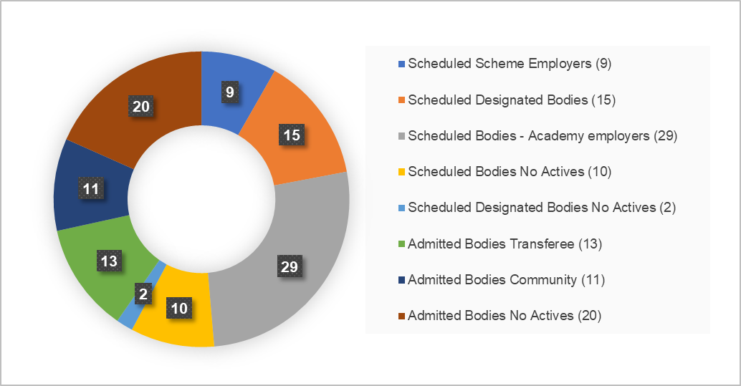

  - Assets under management

    - Asset Classes: The Fund’s ISS articulates how the Fund will responsibly allocate its investments in order to create long-term value for beneficiaries and meet its funding requirements. The ISS includes details of the Fund’s target investment asset allocation, as summarised below along with the actual amounts invested as at 31 March 2025.

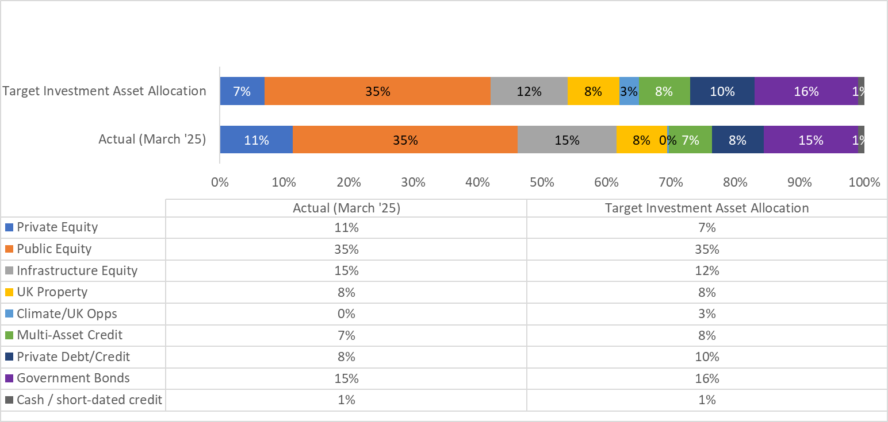

  - Investment time horizon & how the needs of beneficiaries have been reflected in stewardship & investment aligned with an appropriate investment time horizon.

    - The Fund is a defined benefit pension scheme which is open to new members. This means that pension benefits are payable over a considerable timescale and that timescale continues to extend as new benefits accrue. As such the needs of the beneficiaries are long-term and, in recognition of this, the Fund’s investment time horizon is long-term.

    - To ensure that it is able to meet the needs of its beneficiaries over this long timeframe, the Fund seeks to achieve sustainable, risk-adjusted performance of its investments over the long-term. This is reflected in the Fund’s approach to stewardship and investment as set out in the Fund’s FSS and investment beliefs (summarised at 1.2.4).

    - Whilst its ultimate investment horizon is very long-term, the overriding objective of the Fund is to achieve a 100% solvency level over a reasonable time period and maintain sufficient assets in order for it to pay all benefits arising as they fall due. To assist it in achieving this and to inform it of its progress in relation to this objective, the Fund sets a deficit recovery period as part of its triennial valuation for those scheme employers with a funding level of below 100%.

    - The triennial actuarial valuation relevant to 2024/25 was undertaken as at 31 March 2022 and the deficit recovery period agreed by the Fund and its Actuary at that time was an average recovery period of 10 years.

  - Seeking the views of beneficiaries – how and the reason for the chosen approach:

Responsible Investment

    - A new Responsible Investment policy for the Cumbria Pension Fund was approved by Pensions Committee in March 2024. This was informed by a body of evidence collated through a wide and extensive engagement process with the Fund’s beneficiaries and other key stakeholders including Cumbria Divest. This innovative approach to policy development was recognised by the Fund being shortlisted for the “ESG Innovation” category of the LGC Investment Awards 2024.

Other Beneficiary Engagement

    - The Fund’s framework for communications and its communication programme is set out in its Administration & Communications Policy. This includes information relating to both methods and frequency of communications to beneficiaries (which are referred to as ‘stakeholders’ in the policy).

    - Local Pension Board (the LPB): As detailed in Principle 2 the LPB’s role is to assist the Administering Authority to fulfil its functions in relation to all aspects of governance and administration of the Pension Fund. The Board is comprised of representatives from scheme employers and scheme membership to ensure that beneficiaries needs are taken account of by the Fund.

    - Cumbria Pensions Forum (the Forum): As detailed in Principle 2 the purpose of the Cumbria Pensions Forum is to seek the views of stakeholders within the Cumbria Pension Fund and provide information on performance across the management disciplines of the Fund and discuss items of common interest in relation to pensions. The Forum meets annually.

    - Formal consultations with employers: In addition to the above channels for communications with beneficiaries, the Fund also undertakes formal and informal consultations with employers including:
- where it is proposing material changes to its Administration Strategy;
- where it is proposing material change to its FSS; and
- during the triennial valuation process.

  - How the Fund communicates with its beneficiaries

    - The Fund communicates with its beneficiaries in a number of ways including, but not limited to:

- Maintenance of the Fund’s website at www.cumbriapensionfund.org. This is designed to improve both the accessibility of Fund information (including its stewardship activities) and its ability to engage in dialogue with its stakeholders. It provides scheme members, scheme employers and other interested parties with key information about the Fund and the wider LGPS. The website is regularly reviewed and updated to ensure it remains fit for purpose.
- The Fund’s pensions administrator – Local Pensions Partnership Administration Ltd (LPPA) – has a clear plan of core communications to members on matters such as annual allowances, member annual benefit statements and pensions increase. In addition to this, LPPA provides members with an annual newsletter which provides information on key issues and news in relation to LGPS pensions.
- Publication of the Fund’s Annual Report including the audited Financial Statements of the Fund.
- Publication of reports presented to the various governance bodies associated with the Fund on the Administering Authority’s website. Where appropriate these reports link to other relevant sources of information, for example BCPP stewardship and voting reports.

SUMMARY OUTCOME: The Pension Fund is keen to listen to the views of beneficiaries and use these to inform the development of policies, for example the wide engagement undertaken to support the development of the Fund’s Responsible Investment policy.

Feedback during 2024/25 and beyond from the channels referenced in section 6.5 indicates that the Fund’s chosen approach is effective.

  - Future Developments:

    - In developing the 2024/25 Annual Report, the Fund will recognise the new reporting structure required by the Scheme Advisory Board to provide consistent and comparable data for all funds. This Annual Report will be published on the Fund’s website by 1 December 2025 in compliance with LGPS Regulations.

PRINCIPLE 7: Signatories systematically integrate stewardship and investment, including material environmental, social and governance issues, and climate change, to fulfil their responsibilities.

  - Introduction

    - As detailed in Principle 1, the Fund’s investment beliefs and approach to assessing investments are set out in its ISS. This includes our belief, as long-term investors, that integrating ESG considerations into the investment management process improves risk adjusted returns. As such, the Fund seeks to systematically integrate stewardship and investment to fulfil its responsibilities as set out below.

  - Investing with BCPP

    - As previously noted, BCPP is the Fund’s chosen approach to meet Government’s requirement to pool LGPS investment assets. A significant benefit of the BCPP pool is that it has an in-house dedicated responsible investment team along with an external specialist stewardship partner – Robeco. This means that it is able to effectively integrate responsible stewardship throughout its investment process.

    - Details of how BCPP does this are set out in its Responsible Investment (RI) Policy (section 9.2.3 of this report describes how the policy has been formulated in conjunction with partner funds including Cumbria), key elements of which are summarised below.

    - Overall approach: ESG factors are fully incorporated into BCPPs investment decisions across all investment portfolios and asset classes. Indeed BCPP have recently appointed a RI Integration Manager.

    - Factors considered: BCPP focusses on those which could cause financial and reputational risk. Of particular relevance are factors which could cause environmental and reputational risk ultimately leading to a reduction in long-term value. Issues considered include, but are not limited to:

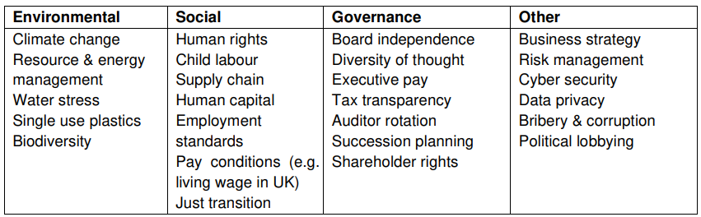
    - Integration into internally managed listed equities: ESG data and research from specialist providers is used alongside general stock and sector research. It is an integral part of the research process and when considering portfolio construction, sector analysis and stock selection. The Head of RI works with colleagues to ensure they are knowledgeable and fully informed on ESG issues. Information from engagement meetings is shared with the investment team to increase and maintain knowledge, and ensure voting and engagement is not detached from the investment process.

    - Integration into externally managed listed equities: RI is incorporated into the external manager appointment process including the ‘request for proposal’ (RFP) criteria and scoring and the investment management agreements. The RFP includes specific requirements relating to the integration of ESG by managers into the investment process which includes assessing and mitigating climate risk, and to their approach to engagement. BCPP expect to see evidence of how material ESG issues are considered in research analysis and investment decisions.

    - The monitoring of appointed managers by BCPP includes assessing stewardship and ESG integration into the investment process and ongoing management of the investments held in accordance with the approved policies. Both the BCPP Investment Committee and the Funds Pensions Committee require that all asset managers report on stewardship and ESG matters on a regular basis and be responsive to any queries fund managers to become signatories or comply with international standards applicable to their geographical location.

    - BCPP encourage managers to become signatories to the UN-supported Principles for Responsible Investment (‘PRI’) and consider the PRI assessment results in the selection and monitoring of managers. They also encourage managers to make a firm wide net zero commitment and to join the Net Zero Asset Manager initiative (NZAM) or an equivalent initiative.

    - Integration into Private Markets: The assessment of ESG issues is integrated into the investment process for all private manager investments. This includes assessing a manager’s ESG strategy through a specific ESG questionnaire and supplementary interviews. Managers are requested to report annually on the progress and outcomes of ESG related values and any potential risks and ongoing monitoring includes identifying any possible ESG breaches and following up with the managers concerned.

    - The ESG questionnaire is agreed with the Head of RI and reviewed by the Alternatives Investment Team on an annual basis. During the year, minor changes were made including additional questions on biodiversity, human rights and diversity.

    - Nearly all metrics showed a noticeable improvement. One significant finding was the percentage of private equity general partners (GPs) reporting to the ESG Data Convergence Initiative (EDCI) rising from 50% in 2024 to 78% in 2025. This Initiative aims to foster consistent ESG reporting thereby increasing comparability and allowing investors to make better informed decisions.

  - Investing with other Investment Managers

    - The Fund considers the ESG credentials, policies and procedures as part of the appointment process for all prospective managers with the aim of ensuring that ESG is well established in the managers appointed. All Managers are now either signatories to or working towards the new requirements of the Stewardship Code 2020. The Fund expects its Managers to incorporate ESG factors into their investment process and demonstrate the outcomes being achieved through this activity. The Fund continues to develop how it incorporates RI within the ongoing monitoring of all managers, including private markets. See Principle 8 for further details.

    - The Fund monitors the asset manager’s stewardship activities, including their involvement in collaborative engagement activities, such as supporting the Transition Pathway Initiative (TPI), and Climate Action 100+. For further information relating to Collaborations see Principle 10.

    - The Fund has developed a questionnaire to draw out how managers incorporate ESG factors into decision-making for new investments as well as ongoing monitoring of managers and the underlying investments especially in the less established asset classes of private markets, which they continue to send out on an annual basis. The questionnaire is reviewed annually to take account of developments within the ESG arena, and this has led to the addition of further questions in relation to net zero and climate metrics. Responses have continued to improve in quality over time with observations very much in line with BCPP in 7.2.7 above.

    - Examples of how the Fund and its other Investment Managers integrate stewardship and investment include:

- Passive Global Equity - Legal & General (LGIM):

Although LGIM do not actively choose the investments in the underlying companies within the index, they aim to use their influence and scale to promote better regulation to improve the entire market as a key driver of long-term growth. This includes working with key policymakers, such as governments and regulators, and collaborating with asset owners to bring about positive change. A key pillar of their approach to index strategies is active ownership: encouraging companies to consider sustainability risks, develop resilient strategies and consider their stakeholders. Further information regarding their approach to ESG integration in relation to indexed funds can be found at: LGIM How to integrate ESG into the investment process.

LGIM have developed proprietary ESG scores for companies (LGIM Methodology for rating companies)

Through a partnership between the Index and Investment Stewardship teams, and have made them publicly available for thousands of companies who can identify and tackle gaps in their strategies and their disclosures, thereby contributing to better market outcomes. Their Stewardship Code 2024 can be viewed on their website and provides further examples of their ESG integration.

- Multi Asset Credit Fund - CQS:

The integration and assessment of stewardship and ESG factors is embedded into their investment process across the CQS platform, both in public and privately held companies.
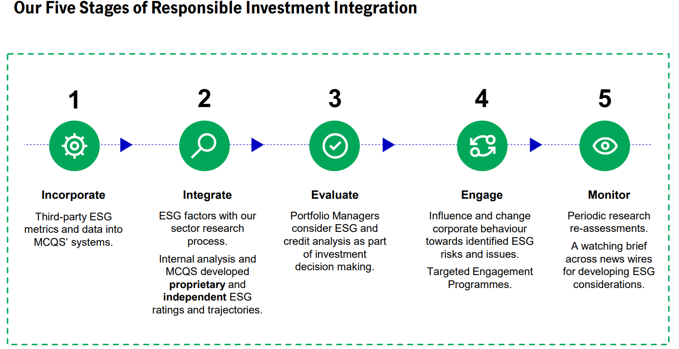

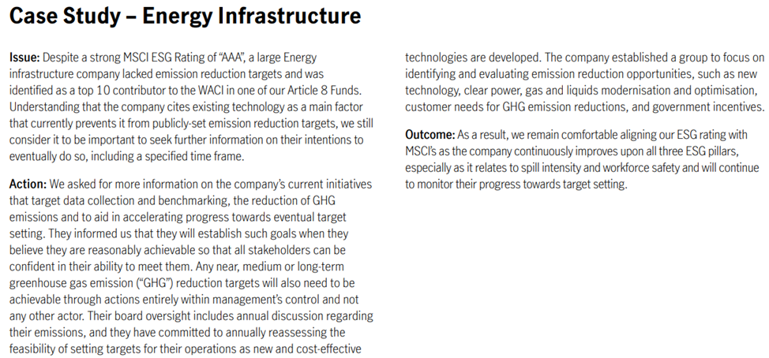
- Infrastructure - JP Morgan (JPM) Infrastructure Investment Fund (IIF)

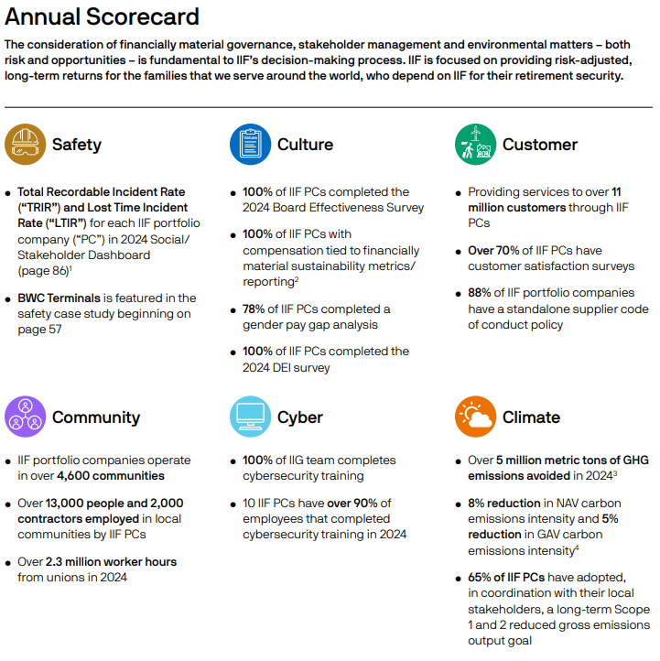

(Source: IIF 2024 Sustainability Report)

Further information regarding their approach to ESG integration can be found in the following report at JPM ESG Integration.

SUMMARY OUTCOME: The Pension Fund works with BCPP and its other investment managers to systematically integrate stewardship and investment, including material ESG issues and climate change to fulfil its stewardship responsibilities.

  - Future Developments:

    - The improvements in responses to private manager questionnaires from last year have led to much greater disclosure of information. For example, this year Barings included details of how they made the decision not to finance the acquisition of a cloud-based logistics management platform for the offshore energy industry. The company exhibited an attractive credit profile but half the firm’s revenue stemmed from high- risk jurisdictions with legal and governance regimes that have in the past been prone to allegations of bribery and corruption, particularly within the oil and gas sectors.

    - The Fund plans to continue to work with Investment Managers to make improvements in reporting ESG integration across all asset classes including that that are less developed in this area, for example:

- The Fund will maintain a dialogue with Investment Managers (including BCPP) about the extent to which ESG factors are incorporated into the manager selection process; and
- The Fund will continue to develop its annual ESG questionnaire it sends to managers. See Principle 8.

PRINCIPLE 8: Signatories monitor and hold to account managers and/or service providers.

  - Introduction

    - As described in Principle 7 ESG integration involves assessing, monitoring and engaging with investment managers. The monitoring aspect is covered in more detail within this Principle. By closely monitoring investment managers and other service providers, the Fund can continuously review their policies, procedures and portfolio positioning to ensure alignment with the Fund’s underlying investment beliefs and objectives. The Fund monitors its investment managers and service providers, to hold them to account in the following ways:

  - Investment Managers

    - Ongoing performance is reviewed quarterly in addition to the annual and longer-term investment performance being reviewed in detail. The Fund operates a three tier performance monitoring framework:

    - Tier 1: Officers and Advisors undertake detailed monitoring of Investment Managers. This includes the following activities, the outcomes of which are subsequently summarised and reported at tier two and three as appropriate.

- Quarterly monitoring of investment performance of the Investment Managers against both benchmark and target returns.

- Monitoring ESG activities – the Funds sends out an annual RI-ESG questionnaire to all investment managers for completion. The questions are designed to improve the Fund’s level of understanding of their Investment Managers activities in this area whilst at the same time assisting with production of this Stewardship Report. All Managers responded within the given timescale and the information provided has been reviewed internally. This questionnaire is updated on an annual basis to further enhance the Fund’s understanding of the work undertaken on its behalf by Investment Managers across all asset classes.

- Investment managers are regularly reviewed, with Officers and Advisors informing the ISG and escalating any issues as necessary.

- An annual review of Investment Manager Internal Control Reports - this review seeks to ensure that Managers exercise reasonable care and due diligence in its activities on behalf of the Fund. Any concerns identified are reported to the Committee and the managers are challenged to explain any weaknesses.
- All investment managers have clear written mandates, governed by the Fund’s strategic objectives and Pension Investment Regulations and are reviewed regularly by officers and the Committee.

- Local Authority Pension Performance Analytics (LAPPA): Using LAPPA (through PIRC) enables the Fund to view its investment performance within a long-term, peer group context and provides some insight on the degree of skill that is being brought to bear on the Funds management, enhancing governance and improving decision making. The peer group Universe constructed by LAPPA currently comprises 62 funds with an aggregate value of £275bn (over two-thirds of local authority pension fund assets). The Fund receives quarterly reports.

- CEM Benchmarking: CEM benchmarking compares cost, performance and risk against a universe of local and global public and private pension funds. The annual CEM report provides an independent means to validate strategy and provide accountability.

    - Tier 2: the ISG monitors individual manager performance on a quarterly basis. The ISG is responsible for the establishment and review of performance benchmarks and targets for investment. The ISG receives a quarterly report which sets out performance results and a broad range of metrics, with any items of concern highlighted from the Tier 1 monitoring by Officers and Advisors. The ISG also have access to the full reports covering every manager. Should there be any items of concern following discussions, the ISG escalates such matters to the full Pensions Committee.

    - Tier 3: The Pensions Committee review the total Fund investment performance against its bespoke total benchmark return and receive a report on performance from the ISG (both on a quarterly basis). The Pensions Committee is responsible for strategic decision making and oversight, hence makes ‘hire/fire’ decisions of managers and reviews issues if escalated from the ISG.

  - Monitoring of the Fund’s chosen pooling provider - BCPP:

    - In recognition of the important role that BCPP plays, the Fund – along with its partner funds in the pool - has enhanced monitoring arrangements with the company. These are described in Principle 2 at sections 2.3.4 and 2.3.5 of this report.

  - Monitoring other Service Providers

    - Investment Advisors: Committee members are surveyed regularly for their views on quality of advice given by the Investment Advisors. Furthermore, the Investment Advisors are monitored annually against an agreed set of objectives. Monitoring during 2024/25 identified that the service provided met the needs of the Fund.
    - Investment Consultants: Cumbria Pension Fund appoints investment consultants for advice on specific tasks. In 2024/25, Isio Group Ltd were contracted to undertake a review of the structure and composition of the Fund’s public and private equity portfolio. As part of the procurement process clear objectives were set for the consultants with progress against these being regularly reviewed by Officers of the Fund.

    - Custodian: Performance is assessed on a quarterly basis against a number of key performance indicators (KPIs) and on at least an annual basis in a formal review meeting. Monitoring during 2024/25 identified that the service provided met the needs of the Fund.

    - Pensions Administration: The Fund meets with senior officers of Local Pensions Partnership – Administration (LPPA) on a quarterly basis to review the performance against a number of key performance indicators. A Director from LPPA attends the LPB on a quarterly basis to provide an update to LPB members on key issues within LPPA and across the LGPS. Outside of these formal meetings, Officers liaise with LPPA managers on a regular basis to keep updated on developments and understand any emerging issues. Monitoring during 2024/25 identified that the service met agreed performance targets however further work is required within LPPA to provide an efficient end-to-end administration service for scheme members and employers.

    - Actuary: Monitoring takes place via annual review meeting with officers and regular feedback during the year. Monitoring during 2024/25 identified that the service provided met the needs of the Fund.

    - Legal Advisors: Monitoring takes place via annual review meeting with officers and regular feedback during the year. Monitoring during 2024/25 identified that the service provided met the needs of the Fund.

SUMMARY OUTCOME: The Pension Fund regularly reviews its processes including those used to monitor and hold to account its investment managers and service providers to ensure services have been delivered effectively and for the benefit of the Fund’s beneficiaries.

  - Future Developments:

    - The Fund will continue to monitor and review its processes associated with monitoring investment managers and service providers to ensure these remain fit for purpose.

PRINCIPLE 9: Signatories engage with issuers to maintain or enhance the value of assets.

  - Introduction & rationale for the Fund’s approach to engagement

    - Evidence shows that pension funds which consider how the companies they are invested in behave in relation to ESG issues, tend to achieve better returns. This accords with the expectations in the Fund’s investment beliefs and reflects our overall attitude to the stewardship of the Fund. As such the Fund is committed to being a responsible owner and believes that responsible investment, incorporating ESG factors (including climate change) into investment decisions, can help to improve the long-term value for investors.

    - The Fund believes that the best way to be a responsible investor and to influence policy change is not through divestment in the first instance but through active engagement. The Fund recognises that, as a medium-sized LGPS pension fund, it has limited resource and is one voice among many shareholders. Furthermore, the Fund employs external fund managers through which it makes its investments. As such, to ensure that it achieves the best outcomes in relation to active engagement, the Fund works collectively with others. The Fund does this through three key means:

- Working with BCPP and our partner funds to agree well-informed and precise objectives for engagement;
- Working with the Fund’s other investment managers to ensure that their approach to engagement is in line with the expectations of the Fund; and
- Through the Fund’s membership of LAPFF.

  - Working with BCPP and our partner funds

    - One of the key benefits of pooling for the Fund is the ‘collective voice’ that pooling assets with other like-minded LGPS funds can bring. To achieve this the Fund has worked with BCPP and partner funds to formulate the company’s approach to RI and active engagement to ensure that (a) it is aligned to the policies of the partner funds (including Cumbria), and (b) that there is appropriate monitoring and challenge to ensure the company’s approach continues to be in line with partner fund requirements.

    - As previously noted in this report, full details of the BCPP’s approach to responsible investment can be found at: BCPP Responsible Investment. This includes the company’s RI Policy ,Corporate Voting Guidelines and Climate Change Policy which form the framework through which BCPP undertakes engagement and voting work on behalf of Cumbria and other partner funds in the pool.

    - BCPP - developing and reviewing objectives: BCPP’s RI and Voting policies were originally developed by BCPP in 2017 in conjunction with its partner funds (including Cumbria), followed by the climate change policy in 2021. Since then, the policies have been formally reviewed annually to reflect developments in best practice and regulation. In addition to this, the policies are also reviewed and revised in response to material developments such as changes in regulations.

    - The annual review process is as follows:

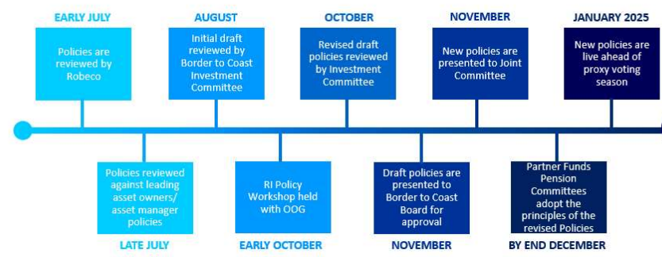
d
c
b
a

Notes on process diagram:

a | The review process includes an evaluation by Robeco (BCPP’s voting and engagement advisor) considering the global context and best practice. This included consideration of the International Corporate Governance Network (ICGN) Global Governance Principles, the UK Corporate Governance Code and the UK Stewardship Code. The policies of best in class asset managers and asset owners considered to be RI leaders were also reviewed to determine how best practice has developed.
b | To assist in the review process, the company held a number of meetings and training with Officers and Members from the 11 Partner Funds. This included:  - a workshop for partner fund Officer Operations Group (OOG) and Advisors on the policy review (14 October 2024).
c | The output of this work was then reflected in the policies and the revised documents were both considered by the BCPP Joint Committee (26 November 2024). At that meeting the Committee agreed to support the revised policies being taken to partner fund Pensions Committees.
d | At its meeting on 10 December 2024 the Cumbria Pensions Committee considered the revised policies and noted that the policies continued to be aligned to the underlying principles of the Fund’s ISS.

    - BCPP - Methods of engagement: BCPP’s approach to engagement varies depending on the asset class and ownership structure. As such their strategy for engagement includes several different strands:
- Direct engagement by BCPP’s internal portfolio managers with companies within their portfolios;
- External managers and Robeco engaging with companies on BCPP’s behalf; and
- Working with LAPFF and a number of RI initiatives. These include Climate Action 100+, the 30% Club Investor Group and Institutional Investors Group on Climate Change (IIGCC) Net Zero Engagement Initiative (NZEI), as detailed in Principle 10.

In addition to this, RI criteria are integrated into BCPP’s due diligence process within Private Markets and the company prioritises engagement with the general partners ahead of investment to ensure managers meet its requirements in this area.

    - Key engagement themes are reviewed on a three-yearly basis using their Engagement Theme Framework and consulting with Partner Funds. The current key engagement themes are:-

Systemic: Environmental: Social: Governance:
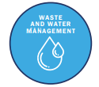

    - The company used the themes in deciding its priorities: in working with Robeco; in considering which collaborations to join; to give focus to its reporting; and in aspects of its investment process for both internally and externally managed mandates.

    - As well as engaging with companies, BCPP also engage with policymakers, regulators and other industry bodies on RI related issues. Some of the ways they do this include membership of industry bodies and initiatives, responding to consultations and engaging with service providers.

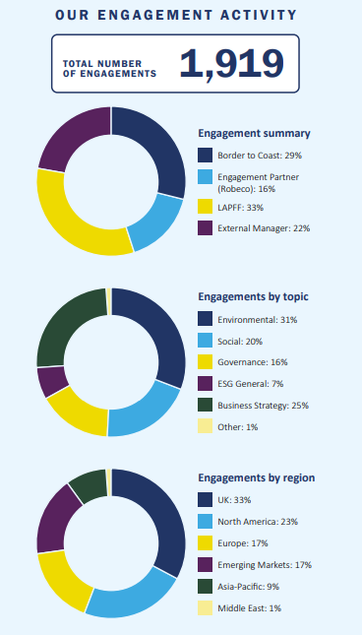
Sourced from BCPP RI & Stewardship Report 2024/25

    - BCPP - Outcomes of engagement: BCPP produces regular reporting on the active engagement it undertakes on behalf of the Fund and our partner funds. The quarterly Robeco Active Ownership Reports and quarterly Stewardship Reports can be accessed via the following link: BCPP Quarterly RI Reports. The examples below provides a flavour of engagement work undertaken and the outcomes:

- Engagement on Just Transition with banks (UK listed equity)
In June 2023 BCPP commenced a new programme of engagement focussing on a just transition to net zero aiming for the integration of a social dimension into climate strategies. They are collaborating with Royal London Asset Management (RLAM ) to engage four UK banks (Lloyds, NatWest, Barclays & HSBC). Banks have a key role to play in the low-carbon transition, via capital allocation and support for customers to transition.

The response has been very positive, with all four banks having made commitments to support a just transition. BCPP attended the NatWest AGM in June 2024 to ask the Chair to consider a formal just transition strategy or integration into existing decarbonisation plans. During 2025, they will assess the banks’ new disclosures against investor expectations and report publicly on progress.
In May 2024, BCPP published ‘Investor expectations on just transition for the banking sector’ to inform deeper engagement and to assess emerging strategy as the banks’ ambition is turned into action.

- Engagement on Social Inclusion and Labour Management
In 2024, BCPP joined the Good Work Coalition, a collaboration of 47 institutional investors, co-ordinated by ShareAction and representing $7.1tn in AUM. Through this they have joined two engagement workstreams:

Living Wage - engaging with FTSE350 companies in the retail sector to become accredited Real Living Wage Employers, paying the Living Wage to both directly employed and third-party staff; and
Racial Inequality - engaging with FTSE350 food sector companies to publish their ethnicity pay gaps and action plans to address these gaps.

They have met with Marks & Spencer, Kingfisher, and Currys to request real Living Wage accreditation, and with Associated British Foods and SSP Group to request Ethnicity Pay Gap reporting. While the retail companies remain resistant to formal Living Wage accreditation, the food sector companies are progressing data collection to enable disclosure. Engagement is ongoing.

Intercontinental Hotels Group (UK Listed Equity Fund) – this British hotel franchise is being engaged along with other companies in the retail and hospitality sectors, where the pandemic exposed vulnerabilities and a lack of safeguards for workers. At the start of the engagement, the company struggled to identify and manage labour practices among some of its most vulnerable workers, such as those employed by third-party service contractors like cleaning or security firms. However, progress has been made with the company extending its human rights approach to include key labour practices, such as freedom of association, wages and working hours, and worker health and safety. The company has also rolled out its ‘Responsible Labour Requirements’, a set of mandatory labour-related due diligence standards for its managed hotels when working with sub-contractors and is planning to conduct regional human and labour rights impact assessments to guide further action.

  - Working with the Fund’s other investment managers

    - In addition to investing through BCPP, the Fund currently also invests with a number of other investment managers. The second largest investment manager in terms the value of the Fund’s investments with them is LGIM – as at 31 March 2025 the Fund had approx. £560m of assets with LGIM and approx. £2,088m with BCPP.

LGIM
    - As an investment manager with approximately £1tn+ assets under management, LGIM has a significant voice. Like the Fund, LGIM believes that RI is crucial to mitigate risks, capture opportunities and strengthen long-term returns. As such active engagement with companies and policymakers is a key component of LGIM’s approach to RI. (Details can be found at LGIM CG & RI Principles)

    - Given LGIM’s scale, it is able to engage with the companies it believes can set an example in their sectors but also, crucially, with the regulators and policymakers that set the rules. Particularly given the scale of their assets in index funds (in which Cumbria is an investor), LGIM sees working to promote better regulation to improve the entire market as a key driver of long-term growth.

    - During the most recent annual reporting period (to December 2024) LGIM actively engaged in a number of areas as summarised below – full details of these activities can be found at: LGIM Active Ownership Report 2024

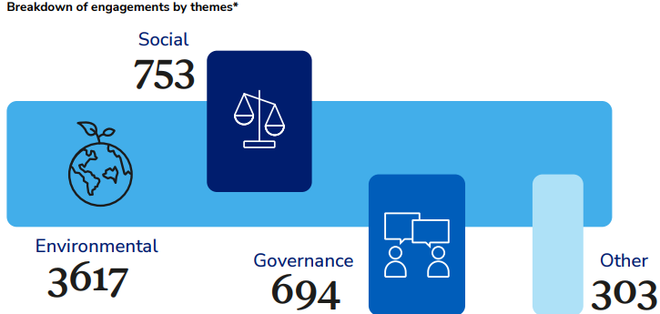

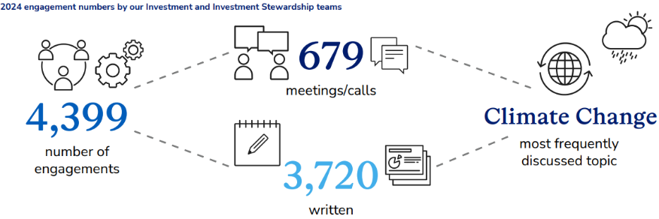



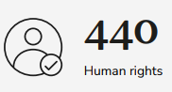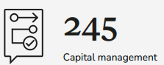


Sourced from: LGIM Active Ownership report 2024

    - LGIM - Outcomes of engagement

LGIM continue to expand the scope of their Climate Impact Pledge engagement programme (CIP) (LGIM CIP Report 2024). Their CIP is a targeted engagement campaign started in 2016 to address the systemic risk of climate change. It now covers 55% of total corporate securities by value that LGIM invests in on behalf of clients (up from below 10% in 2020) and 82% of the total emissions attributable to LGIM’s holdings.

    - LGIM have engaged with more companies than ever before, holding them to account, including through potential voting sanctions or divestment when they do not sufficiently meet expectations. The introduction of baseline expectations led to more companies being identified for voting sanctions in the oil and gas and mining sectors. However, most companies in these sectors that had been subject to voting sanctions in 2023 improved sufficiently to avoid a repeat in 2024.

    - They continued to scrutinise companies’ climate transition plans closely, and co-file or support relevant shareholder resolutions where appropriate. Following extensive engagement, they co-filed a shareholder resolution at Nippon Steel, their first in Japan, due to insufficient climate-related lobbying disclosures. The resolution achieved 27.9% support from shareholders, sending a strong message to the company’s board that investors expect greater transparency on climate-related policy engagement activity. This was also one of the highest levels of support recorded for a climate-related shareholder resolution in Japan.

    - LGIM have also seen progress in the 14 companies that remain on their divestment list. They will continue to engage and push for further change with these and the two additional companies, TJX (retailer) and Glencore (mining), which were added to this list in 2024.

Private Managers engagement:
    - JP Morgan – Infrastructure Investments Fund (IIF), El Paso Electric (EPE). Engaging with this company to reduce carbon intensity over time, set carbon reduction goals and work together with stakeholders and regulators to provide essential services to customers.

    - Progress has been made as goals have been set and published: 80% carbon-free energy by 2035 and 100% pursuit of decarbonization of generation portfolio by 2045. To meet its 2035 goal, EPE plans to expand its generation portfolio with renewable energy and storage solutions, while continuing the use of existing carbon-free nuclear resources and improving efficiencies of new fuel technologies.

    - In 2024, EPE began the development of a solar facility in Texas. The site reached mechanical completion in November 2024 and became commercially operational in January 2025. This expansion has made it possible for 5,000 customers to enrol in the community solar program, offering them access to renewable energy. In addition a Transportation Electrification Plan, approved for 2024-2026, aims to boost electric vehicle adoption through education, rebates, and charging infrastructure.

  - Membership of the Local Authority Pension Fund Forum (LAPFF)

    - Cumbria Pension Fund is a member of LAPFF. LAPFF is a collaborative shareholder engagement group which brings together 87 local authority pension funds and 7 pools (including BCPP) from across the UK with combined assets of £425 billion. As such the Fund is able to enhance its own influence in company engagement by collaborating with other Pension Fund investors through the Forum. LAPFF is a network organisation and a service provider, not an asset owner or asset manager, so it has no conflicts of interest in terms of company ownership. LAPFF seeks to protect the investments of its members by promoting the highest standards of corporate governance and corporate social responsibility (i.e. responsible action by the companies in which its members invest) on ESG issues.

    - LAPFF’s approach to engagement is to build relationships with companies, where possible, and provide robust challenge. It also aims to engage with a broad range of stakeholders to understand as fully as possible the complete set of operational, reputational, legal, and financial risks facing companies and investors.

    - LAPFF - Developing and reviewing objectives:

    - LAPFF hold quarterly business meetings and an Annual Conference which a representative of the Fund regularly attends to ensure the Fund has a full understanding of the work undertaken and to facilitate input into the work programme of LAPFF.
    - LAPFF - Methods of engagement:

    - Like BCPP, LAPFF uses a number of methods of engagement. During 2024 LAPFF engaged with 340 companies Its methods of engagement and stewardship activities are presented in the charts below:

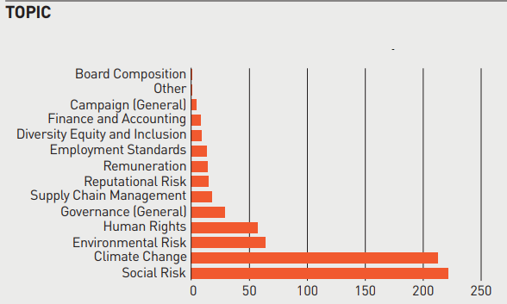

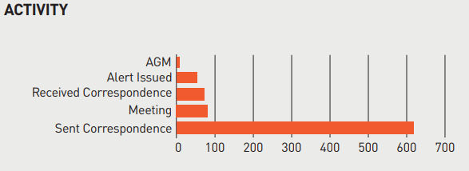

Sourced from: LAPFF Annual Report 2024.

LAPFF - Outcomes of engagement:

    - LAPFF continued its work in the mining sector. LAPFF’s work engaging with affected communities was recognised this year within a UN working group report with the Forum’s approach cited as an example of good practice. LAPFF continued to see signs of progress as a result of their ongoing engagement and will keep seeking improved practices in this sector.

    - LAPFF also continued its work engaging companies on approaches to minimising adverse human rights impacts following a year of growing regional conflict. LAPFF joined an Investor Alliance for Human Rights (IAHR) pilot project which is focused on conflict-affected and high-risk areas (CAHRAs) and also undertook collaborative engagements through IAHR on Uyghur Forced Labour.

    - As joint lead investor in the Climate Action 100+ collaborative initiative, LAPFF continued its long-term engagement with National Grid, attending six of their AGMs, including 2024. They acknowledge that the company’s climate transition plan represented a major step in meeting the growing needs of the energy transition and Net Zero targets. This progress was also reflected in LAPFF’s voting alert this year which recommended support for the transition plan, which received 98% shareholder approval at the AGM. Although significant progress has been made LAPFF will continue its engagement to help facilitate change.

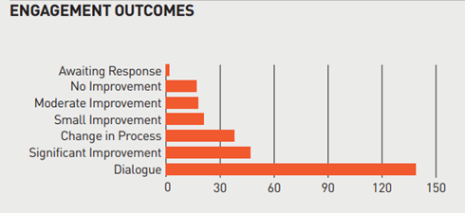

Sourced from: LAPFF Annual Report 2024.

SUMMARY OUTCOME: On behalf of the Pension Fund, investment managers (including BCPP) and LAPFF have continued to engage with companies in which the Fund holds investments to deliver on its ESG objectives. These are reported to the Fund’s Pensions Committee on a quarterly basis through reports which are accessible on the Administering Authority’s website.

  - Future Developments:

    - As a responsible investor the Fund, through its investment managers, will continue to engage with regulators, public policy makers, and other financial market participants on systemic risks to help create a stable environment to enhance long term returns. Additionally, the Fund also undertakes collaborative engagement with other institutional shareholders. The Fund will remain as an active member and supported of LAPFF and encourage them in their campaigns and initiatives.

PRINCIPLE 10: Signatories, where necessary, participate in collaborative engagement to influence issuers

  - Introduction

    - Effective collaboration forms an important part of the Fund’s approach to investment and is incorporated in the Funds investment beliefs as described in Principle 1 at 1.2.4. Accordingly, the Fund collaborates in a number of ways through different organisations and arrangements as summarised below.

  - LAPFF

    - As noted in Principle 9 at 9.4 LAPFF is a key mechanism through which the Fund seeks to participate in collaborative engagement. Through its membership of the Forum the Fund is involved in a range of engagement activities and these include wider collaborations such as:

    - Votes Against Slavery: This is a collaborative engagement supported by LAPFF, drawing support from over 150 investors and targeting companies failing to comply with Section 54 of the Modern Slavery Act. This collaborative approach has proved successful in the past with good success rates across target companies.

    - Nature Action 100+: LAPFF has become increasingly concerned about the investment risks associated with biodiversity and nature loss joining the Nature Action 100+ during the year. This initiative, including 220 institutional investors representing nearly $30tn assets, seeks to ensure companies are meeting investor expectations on mitigating and managing nature-related risks. Through this LAPFF participated in engagements with AbbVie, Merck & Co, Procter & Gamble, Novo Nordisk and Johnson & Johnson.

    - Asia Research and Engagements (ARE): As part of the continued engagement through ARE’s Energy Transition Platform LAPFF aims to support and accelerate the energy transition in Asia. This collaborative initiative focuses on influencing high-emitting companies based in Asia to adopt strategies that align with the goals of the Paris Agreement. Engagement has included meeting with Japanese Banks to discuss their approach to financing the transition.

  - BCPP

    - As previously noted the Fund collaborates with BCPP and other partner funds on an ongoing basis. In addition to working collaboratively with partner funds on RI and engagement matters, BCPP has also been involved in wider collaborative engagement including:

Workforce Directors Coalition: In 2023, BCPP joined the Workforce Directors Coalition and supported the launch of the Workforce Directors Investor Guidance, developed by Railpen with input from BCPP and other industry participants. The guidance highlights the importance of companies effectively engaging and listening to the voice of the workforce in the context of long-term sustainable financial performance. During 2024, the Coalition commenced engagement with 13 focus companies on this issue.

Institutional Investors Group on Climate Change (IIGCC) Net Zero Engagement Initiative (NZEI): This engagement programme is seeking comprehensive Net Zero Transition Plans from 107 target companies outside the scope of CA100+. BCPP is also co-leading engagement with Easyjet with positive progress being made to date regarding emissions targets.

Global Investor Commission on Mining 2030: This was launched in January 2023 The mining sector is considered to play a critical role in the transition to a low-carbon economy. Issues identified are considered to be systemic risks within the sector which the Initiative aims to address.

    - Contributing to UK Government direction: BCPP, alongside pension funds representing some £1.7tn in assets, collaborated on a blueprint recommending specific policy actions to unlock pension capital to further support the UK Government’s goal of achieving clean power by 2030. Recommendations included incorporating the government’s legally binding emissions reduction targets in the National Planning Policy Framework and enabling rapid permitting of the repowering of wind farms through planning reform.

  - Other collaboration and future improvements:

    - Indirect Collaboration: Through its membership of LAPFF and ownership of BCPP the Fund is indirectly involved in the following collaborative organisations:

- Asia Transition Platform
- Climate Action 100+
- ESG Data Convergence Initiative (ESDI)
- FCA Vote Reporting Group
- Global Investor Commission on Mining 2030
- Good Work Coalition
- Investor Alliance for Human Rights
- Institutional Investors Group on Climate Change (IIGCC)
- Investment Association
- Investor Mining and Tailings Safety Initiative
- LGPS Cross Pool RI Group
- Local Government Pension Scheme Advisory Board Code of Transparency
- Nature Action 100+ Initiative
- Net Zero Asset Managers Initiative
- Occupational Pensions Stewardship Council
- Task Force on Climate-related Financial Disclosures (TCFD)
- Transition Pathway Initiative (TPI)
- UK Pension Schemes RI Roundtable
- United Nations supported Principles for Responsible Investment (PRI)
- Workforce Disclosure initiative (WDI)
- 30% Club

SUMMARY OUTCOME: The Pension Fund supports the collaborative engagement undertaken by LAPFF, BCPP and other like-minded investors and organisations to maximise influence in the area of ESG to collectively drive positive change.

  - Future Developments:

    - The Fund is also working to improve how it engages with its other investment managers (see Principles 7 & 8) on their approach to collaborative engagement and exploring participation in further collaborative initiatives during 2024/2025.

PRINCIPLE 11: Signatories, where necessary, escalate stewardship activities to influence issuers.

  - Activity

    - The Fund believes that engagement and constructive dialogue with the companies in which it invests is more effective than excluding companies from its investment universe. However, if engagement does not lead to the desired result then escalation may be necessary. The Fund works with those investing on its behalf to facilitate this.

    - BCPP: to ensure its expectations regarding stewardship activities are met by BCPP the Fund works closely with the company and partner funds to develop and review BCPP’s RI Policy, Corporate Voting Guidelines and Climate Change Policy. Further details of working with BCPP and partner funds are set out in Principle 9. The company’s agreed approach to escalation is set out in section 6.2.2 of its RI Policy and is as follows:

BCPP believe that engagement and constructive dialogue with the companies in which it invests is more effective than excluding companies from the investment universe. However, if engagement does not lead to the desired result escalation may be necessary. A lack of responsiveness by the company can be addressed by conducting collaborative engagement with other institutional shareholders, registering concern by voting on related agenda items at shareholder meetings, attending a shareholder meeting in person and filing/co-filing a shareholder resolution. If the investment case has been fundamentally weakened, the decision may be taken to sell the company’s shares.

    - See 11.2.2 below for an example of BCPP escalation.

    - LGIM: Their engagement processes are based on targeting specific outcomes and leveraging influence to achieve them. They do this through a package of measures that they can escalate in a structured manner. These range from voting sanctions to collaborative engagement and the pre-declaration of their views. Where LGIM have filed or collaborated on select proposals, they have found that they have been an effective means of escalation – both at the individual company level and for market-wide change more broadly. Further information on their approach can be found in their Active Ownership Report 2024, and an example at 11.2.1 below.

    - Other Investment Managers: in the case of other Investment Managers, the Fund recognises that its scale means that it may have limited ‘levers to pull’ to materially beneficially influence the overarching policies of its Investment Managers. The Fund seeks to ensure that its expectations regarding stewardship activities including escalation are met through selecting and appointing ‘best in class’ managers and monitoring them on an ongoing basis. As part of the Annual RI questionnaire sent out to all investment managers they are specifically requested to disclose details of their escalation strategies.

Pantheon (private Equity manager): If engagement with a General Partner is unsuccessful, Pantheon would seek to leverage any available board and advisory seats to further engage in resolving the issue. The ultimate sanction is to decline to invest in the next fund which is a relatively powerful tool as private equity and Infrastructure managers return to their investors every 3-5 years to raise new capital and are generally dependent on the support of their existing investors.

    - LAPFF: as previously noted the Fund seeks to further expand its ability to influence issues through its membership of LAPFF. When LAPFF deems it necessary to escalate an engagement, it sometimes does so through press releases and media outreach more broadly. As a matter of course, LAPFF does not advocate for divestment, but rather for funds to use their holdings, in collaboration with likeminded investors, to engage companies for more desirable outcomes. Promotion of investor engagement is the purpose of LAPFF voting alerts. Tools and initiatives such as Say on Climate are designed to bring about robust dialogue between investors and companies, but dialogue that provides clear expectations that companies can achieve. There are other tools for engagement escalation if it is felt that companies are not being responsive, such as the filing of shareholder resolutions, press releases and media outreach.

  - Outcomes

    - LGIM: LGIM believe they have a responsibility to urge companies to achieve their climate goals by escalating engagement, in collaboration with peers and key industry bodies. For Example at Woodside Energy’s 2022 AGM despite 49% of shareholders voting against the company’s climate report no material changes were incorporated in its subsequent climate transition plans. LGIM continued to be concerned about emissions targets, disclosure on climate-related risks and the quantum of capital to be allocated to low-carbon solutions. At the 2024 AGM, in addition to LGIM voting against the company’s climate transition plan, they also voted against the re-election of the Board Chair, in line with Climate Impact Pledge escalation. The Climate Transition Plan failed to reach requisite shareholder support, with 58.4% voting against its approval.

    - BCPP: see details below of voting escalation at BP & Shell

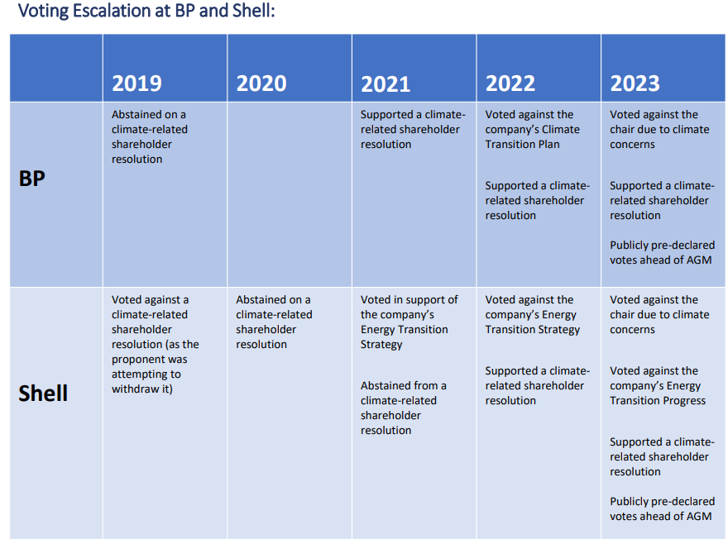

(source: BCPP Proxy voting - AGM season report 2023)

BP: BCPP made public statements in late 2024 in response to reports that BP was weakening its climate targets and transition plans, as part of a “strategy reset”. They co-signed a public letter with 48 signatories representing £5tn in assets under management. They also met with BP to raise concerns. At BP’s AGM in April 2025, BCPP voted against management on an unprecedented number of agenda items, including the re-election of the Chair of the Board and three other directors. They also voted against acceptance of the annual report and against approval of the remuneration report. As part of engagement escalation, they also publicly pre-declared these votes ahead of the AGM. An exceptional 24% of shareholders voted against the re-election of the Chair. Engagement with BP is ongoing.

Shell: At the 2024 AGM, BCPP voted against the re-election of the Chair due to inadequate targets and decarbonisation strategy. As part of engagement escalation, they publicly pre-declared these votes ahead of the AGM. Engagement with Shell is ongoing.

    - LAPFF: Have undertaken a long-term engagement with the restaurant chain Chipotle over material water-related risks, which included the intention of filing a resolution in 2022 which was subsequently withdrawn conditional on prioritisation of water-related assessments and target setting. Following that escalation and through intense dialogue, during 2024 the company published a goal to support water stewardship efforts to conserve and restore watersheds in priority regions.

SUMMARY OUTCOME: Border to Coast and other investment managers have supported various shareholder resolutions during the year and have escalated engagement activities with a number of companies.

The Fund’s Responsible Investment policy clarifies that the Fund retains responsibility in this area and reserves the right to act alone on escalation and exclusion decisions where the collective view does not coincide with its own in material respects.

    - Future Developments:

    - The Fund is working to improve how it engages with its other investment managers (see Principles 7 & 8) on their approach to collaborative engagement and exploring participation in further collaborative initiatives during 2025/2026.

PRINCIPLE 12: Signatories actively exercise their rights and responsibilities.

  - Introduction

    - Exercising Shareholder rights and responsibilities is fundamental to improving investment outcomes. As an asset owner, the Fund uses these rights in order to manage a sustainable and solvent pension fund on behalf of current and future members of the Fund.

    - The Fund recognises that there are regional differences in corporate governance standards and company behaviour. Furthermore, there are also differences between asset classes. The Fund exerts its influence through voting and other means with the aim of getting the best outcomes in the context of each market and asset class it is invested in. 12.3-12.5 below summarises the Fund and its investment managers’ approach to listed equities and 12.6 below summarises the approach to other asset classes.

  - Expectations of asset managers

    - The Fund’s expectations of asset managers are aligned to its statement of investment beliefs which are presented in the Fund’s ISS.

  - Listed equity assets

    - The Fund does not directly hold shares – its investments in listed equities are made through investment managers into pooled investment funds. As such the Fund votes on shareholder resolutions through proxy voting arrangements. The Fund’s holdings in listed equities are managed as follows:

- Actively managed equities - by BCPP (the pensions pooling company jointly owned by the Fund and 10 other Partner Funds); and
- Passively managed equities - by LGIM.

    - Investment managers are expected to approach the subject of voting with the same care and attention as other matters which influence investment decisions and voting should be undertaken where it is believed to be in the best interests of the Fund. Where a resolution is put forward which is deemed to be controversial, investment managers should liaise with the Fund as appropriate.

    - The Fund’s investment managers are required to report quarterly on their voting actions for every appropriate investment. Any responses received from companies concerned should also be reported. Both should hold and make available to the Fund a full voting audit trail.
    - Officers hold regular Review meetings in addition to ongoing dialogue with asset managers, in which they communicate expectations of the Fund in respect of either voting (listed equities) or holding them to account (privately held companies). Effective stewardship is an integral part of performance reviews of all asset managers.

    - Fund voting policy: The Fund’s voting policy is set out in its ISS and within its RI Policy. As per the policy, responsibility for the exercise of voting rights is currently delegated to the investment managers. A process is available to allow the Fund to vote its proportion of any shareholding in a different way to that adopted by BCPP should there be a difference in interpretation of the voting guidelines. This is also set out in the Stewardship section of BCPP’s RI Policy.

    - Monitoring shares and voting rights: The Fund formally monitors what shares and voting rights it has on a quarterly basis. The outcome of this quarterly process is reported to the Pensions Committee as part of the quarterly Review of Oversight and Governance reports which are a standing item on the Committee agenda.

    - Reporting: The Fund publishes its voting activities on its website at: Share Voting Records. In addition to this, the Pensions Committee is kept informed on relevant corporate governance issues arising during the period and details of this, including voting activity, are formally reported to it on a quarterly basis. The Fund’s Annual Report also incorporates disclosure of its voting and engagement activity. The Annual Report for the year ended 31st March 2025 is due to be published by 1 December 2025 and will be available on the Fund’s website.

  - Listed equity assets – BCPP

    - Voting policy: BCPP’s Corporate Voting Guidelines set out the parameters for how votes are cast. The document is reviewed and updated annually following dialogue with partner funds including Cumbria. The policy is also reviewed by Robeco, using the International Corporate Governance Network Global Principles, the UK Stewardship Code and the UN Principles for Responsible Investment as benchmarks. The Corporate Voting Guidelines (which should be read in conjunction with BCPP’s RI Policy) set out the voting approach in term of key areas of corporate governance e.g. Climate Change, Company Board compositions, Director’s remuneration, other issues including stakeholder engagement, auditor independence, political donations, lobbying and shareholder rights.

    - Proxy voting arrangements: BCPP uses a proxy voting platform, with proxy voting recommendations produced for all meetings voted, that is managed by Robeco as the Voting & Engagement provider. Robeco’s proxy voting advisor (Glass Lewis. Co) provides voting recommendations based upon BCPP’s Corporate Voting Guidelines. All of Robeco’s voting recommendations are reviewed by the BCPP RI team and portfolio managers prior to votes being executed.

    - Stock lending: BCPP has an active stock lending programme. Where stock lending is permissible, lenders of stock do not generally retain any voting rights on lent stock. Procedures are in place to enable stock to be recalled prior to a shareholder vote. Stock will be recalled ahead of meetings, and lending can also be restricted including but not limited to, if the resolution is contentious, the holding is of a size which could potentially influence the voting outcome or BCPP has co-filed a shareholder resolution.

    - Reporting: Details of the voting activity undertaken by BCPP can be found at: BCPP RI Voting Reports. Headline numbers for voting activity across all BCPP equity funds during the year 2024/25 are summarised below:

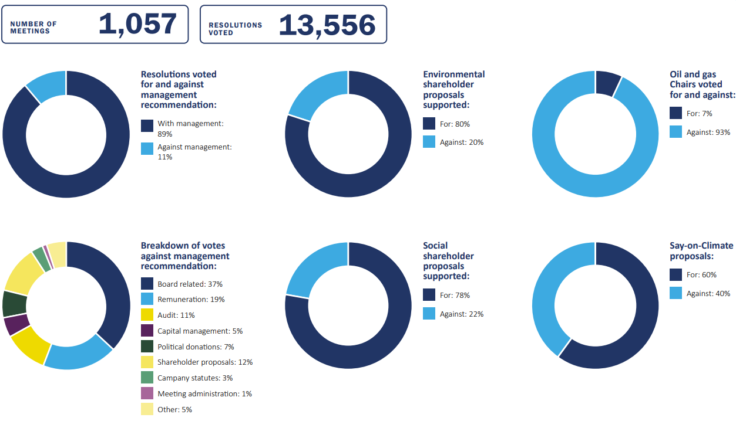

Source : BCPP RI & Stewardship Report 2024/25

    - Details of votes withheld and abstentions for the funds in which the Cumbria Fund are invested are included in the quarterly voting reports:
- Votes withheld - there were 30 votes withheld during the year which related to election/re-election of directors at US companies. Examples included failing to incorporate basic considerations for gender diversity at Fiserv Inc and the Chair of the remuneration and audit committees not being independent at Meta Platforms Inc.
- Abstentions - there were 31 abstentions during the year. Many of these related to election of directors where a more suitable candidate was preferred but the nominee was supportable, for example at Prada S.p.A.

    - Details of all votes against management are included in the quarterly voting reports. Key areas of votes against management were:
- the appointment of Auditors where the tenure and/or the fees were considered to be excessive;
- Board appointments where Boards were deemed to lack sufficient diversity or individuals to lack independence;
- Remuneration Policy and/or reports where they do not meet the criteria set out in BCPP’s voting guidelines; and
- opposing all political donation due to reputational risks and democratic implications.

  - Listed Equity Assets - LGIM

    - Voting policy: LGIM notes that its voting activity forms an important part of its engagement strategy and that enables it to escalate its concerns through the use of shareholder rights. LGIM believes the most efficient and effective way of achieving mutual goals through voting and engagement is to speak with one strong voice. Further information relating to LGIM’s voting can be found in the links below:
  - The voting disclosure page: LGIM Voting Disclosures
  - The quarterly ESG impact reports and details of LGIM’s stewardship policies can be found at: LGIM Investment Stewardship.

The Cumbria Fund is invested in LGIM’s World Equity Index.

    - Proxy voting: LGIM has a general stewardship policy supplemented by specific market polices. LGIM uses voting research from Institutional Shareholder Services (ISS), Institutional Voting Information Service (IVIS), Glass Lewis and voting decisions incorporate their own research analysis and engagement activities where appropriate. LGIM uses the ISS voting platform “ProxyExchange” to vote its shares.

    - Stock lending: Where there are no legal or practical impediments, LGIM aim to vote with every share they hold. They have procedures in place that only allow shares to be lent up to agreed thresholds and they always retain a number of shares in each voteable stock to be able to note their approval, or dissent, through a vote via the shareholder meeting. They also retain the right of recall of their shares, should we deem this necessary or expedient.

    - In practice, they do not typically recall lent stock for voting on routine company meetings. However, if there were a material vote – for example, a potential takeover of a company that they owned at a price which they did not believe was in the best interests of shareholders, they would recall any stock that was out on loan in order to vote with 100% of their holding.

    - Reporting: Details of the voting activity undertaken by LGIM across all its investments can be found at: LGIM Voting Disclosures.* Details of vote instructions are disclosed by LGIM on a per-meeting basis with the rationale for all votes cast against management available via the above link.

*The figures reflect the voting activities across LGIM – i.e. they are not limited to the Fund’s holdings in LGIM’s World Equity Index pooled fund.

  - Fixed income and other asset classes

    - For assets other than listed equities, actively exercising rights and responsibilities is generally more challenging. This is because the Fund doesn’t engage in direct investment itself but instead invests through external investment managers with the majority of these investments made via pooled funds. As such, the Fund has little or no ability to influence granular investment matters such as seeking amendments to terms and conditions in indentures or contracts, impairment rights, and seeking access to information provided in trust deeds. Instead, the Fund has sought to actively exercise its rights and responsibilities through investing with ‘like-minded’ investment managers and through the pooling of its investment assets with BCPP.

    - For example:
  - As previously noted, the assessment of ESG issues is integrated into BCPP’s investment process for all investments.
  - BCPP note that a manager’s ESG strategy is assessed through a specific ESG questionnaire, agreed with BCPP’s Head of Responsible Investment, and reviewed by the company’s Alternatives investment team.
  - Managers are requested to report annually on the progress and outcomes of ESG-related values and any potential risks. Ongoing monitoring includes identifying possible ESG breaches and following up with the managers concerned, as well as tracking improvements and targets met.
  - Further details on integrating ESG factors across all asset classes including fixed income, private markets and real estate can be found on pages 15-16 of BCPP’s RI & Stewardship Report 2024/25.
  - Further details of the governance structure of BCPP and how this enables the Fund to have appropriate oversight of the company and hold it to account so as to ensure to the effective stewardship of the Fund’s assets invested is set out in Principle 2.

    - In addition to ensuring investment managers are the right ‘fit’ on appointment, the other key tools used by the Fund to exercise its rights and responsibilities for investments in assets other than listed equities are ongoing engagement with and the monitoring of its investment managers. The Fund will continue to enhance its approach to engagement with its investment managers on ESG and RI matters.

  - An example of how the Fund is seeking to improve its engagement with investment managers on RI matters is the ESG questionnaire which is sent out to the Fund’s investment managers on an annual basis. The questionnaire is reviewed annually to take account of developments within the ESG arena, and this has led to the addition of further questions in relation to net zero and climate metrics.

  - Examples of outcomes of resolutions voted on in the year to 31st March 2025

    - Climate change continues to be an area of major focus for companies and their shareholders and remains a priority for Scheme members and employers in the Fund. BCPP strengthened their voting guidelines during the year regarding climate change to support their net zero commitment. This enhanced voting policy on climate has led to significant votes against management at AGMs including voting against the re-election of the Chair of the Board at 93% of oil and gas companies due to inadequate transition plans (e.g. Shell, BP & Woodside Energy Group). Pre and post company engagement accompanied these votes and BCPP pre-declared their voting intentions ahead of many of the AGMs.

    - BCPP & National Grid (UK Listed Equity): At the 2024 AGM, BCPP voted in support of the company’s climate transition.

  - When National Grid first put its climate transition plan to a vote in 2022, BCPP viewed it as insufficient and voted against it. In 2023, they escalated their voting by opposing the re-election of the Chair of the Board. However, BCPP deem this year’s updated climate transition plan to have improved significantly and have therefore supported both the plan and the Chair of the Board. The updated climate transition plan was well received by shareholders, garnering almost full support at 99%.

    - BCPP & Amazon Inc (Global Equity Alpha): The 2024 AGM agenda of retail tech giant Amazon covered topics spanning the breadth of ESG.

  - Executive Pay - the company’s longstanding executive pay practices, consisting of discretionary equity grants without performance conditions, led BCPP to vote against the Say on Pay proposal.
  - Environmental issues - BCPP supported three shareholder proposals asking the company to report and set goals for plastic packaging reduction, to measure and disclose Scope 3 emissions, and to prepare a report on its just transition strategy.
  - Social issues - BCPP supported a shareholder proposal requesting the company to conduct an audit of warehouse workers’ conditions and a proposal asking for an assessment of Amazon’s adherence to its Human Rights Principles.

More details on key voting can be found in Proxy Voting: AGM Season Report 2024

and BCPP RI & Stewardship Report 2024/25.

    - LGIM - Spotlight on the oil & gas sector: LGIM encourage companies to put forward ambitious and credible climate transition plans to a vote, and have published their expectations of what they would like to see in order to be able to support them. Four major oil and gas companies (see table below) put their climate transition plans to the vote in quarter 2 of 2024:-

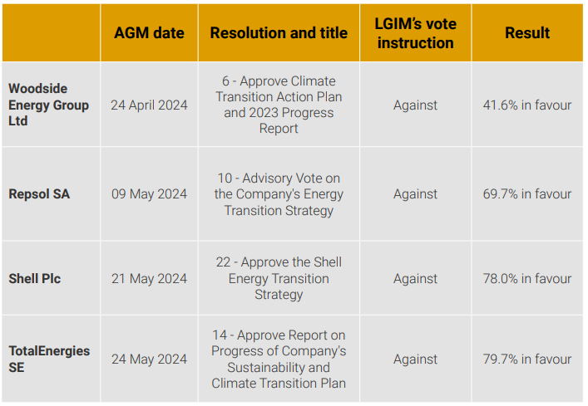

Although LGIM did not support any of these plans they did acknowledge progress has been made at both TotalEnergies SE and Shell Plc.

The level of dissent at Woodside Energy Group’s AGM was very high. Despite the significant proportion of shareholder votes (49%) against the company’s climate report at their 2022 AGM no material changes were incorporated in their most recent climate transition plan. LGIM remain concerned about the emissions targets, lack of quantifiable disclosure on climate related risks and the quantum of capital to be allocated to low-carbon solutions. LGIM also voted against the re-election of the Chair, in line with their Climate Impact Pledge escalation.

SUMMARY OUTCOME: The Fund’s Responsible Investment policy notes that the Fund expects its investment managers to use the voting rights of investments, held on behalf of the Fund, to promote and support good corporate governance principles.

BCPP and other investment managers actively vote the Fund’s shares including on relevant shareholder resolutions. Examples of this this are presented above and also reported to Pensions Committee on a quarterly basis.

APPENDIX A: GLOSSARY

Actuarial Valuation – An actuary formally reviews the assets and liabilities of the pension Fund and produces a report on the Fund’s financial position.

Alternatives – Investment products other than traditional investments of stocks, bonds, cash or property. The term is used for tangible assets such as infrastructure, property, art, wine etc., and financial assets such as commodities, private equity, hedge funds, venture capital, royalties / patents and derivatives.

Asset Allocation – Distribution of investments across asset categories, such as cash, equities and bonds. Asset allocation affects both risk and return, and is a central concept in financial planning and investment management.

Beneficiaries (in relation to Stewardship) – In this context the Stewardship Report refers to Scheme Members and Scheme Employers.

Bonds – Certificate of debt issued by a government or company, promising regular payments on a specified date or range of dates, usually with final capital payment at redemption.

CIPFA – Chartered Institute of Public Finance & Accountancy.

Class Action – An action where an individual represents a group in a court claim. The judgement from the suit is for all the members of the group (class).

Corporate Governance - The system of rules, practices and processes by which a company is directed and controlled and involves balancing the interests of the many stakeholders in a company.

Custodian – Organisation which is responsible for the safekeeping of asset, income collection and settlement of trades for a portfolio, independent from the asset management function.

Deficit recovery period – A reasonable period of time over which a pension fund will aim to repair its funding level to meet its statutory objective of 100% solvency, taking into account employer circumstance where possible.

Defined Benefit – An employer-sponsored retirement plan where employee benefits are assessed based on a formula using factors such as salary history and duration of employment. Public sector pension schemes, including the LGPS, were defined benefit prior to the introduction of the Career Average Revalued Earnings (2014) Scheme.

Divestment – The reduction of some kind of asset for financial, ethical, or political objective. A divestment is the opposite of an investment. For investors, divestment can be used as a social tool to protest particular corporate policies.

Engagement - A series of actions investors can take to reduce environmental, social and governance risks. This can include raising concerns or making proposals about company practices directly to its directors via correspondence, face-to-face meetings, attendance and voting at shareholder meetings.

Equities – Ordinary shares in UK and overseas companies traded on a stock exchange. Shareholders have an interest in the profits of the company and are entitled to vote at shareholders’ meetings.

ESG - Environmental, Social and Corporate Governance

Fiduciary Duty - A legal obligation of one party to act in the best interest of another. The obligated party is typically a fiduciary, that is, someone entrusted with the care of money or property.

Funding Level – The ratio of a pension fund’s assets to its liabilities. Normally relates to defined benefit pension funds and used as a measure of the fund’s ability to meet its future liabilities.

IFRS – International Financial Reporting Standards. Aim to standardise the reporting and information disclosed in the financial accounts of companies and other organisations globally.

Infrastructure - The public facilities and services needed to support residential development, including highways, bridges, schools, and sewer and water systems. A term usually associated with investment in transport, power and utilities projects.

MHCLG - Ministry of Housing, Communities and Local Government (known as DLUHC – Department for Levelling Up, Housing and Communities, to July 2024).

Multi-Asset Credit – MAC is a term used for a fund investing in a range of investments that are classed as ‘credit’ i.e. fixed income, and will often include corporate debt, loans directly to companies, absolute return bonds, emerging market debt, asset-backed securities, real-estate debt and high yield bonds. The MAC fund will aim to be diversified across many asset types (also known as Diversified Credit).

Partner Funds - The term used to describe the 10 other LGPS Pension Funds who are equal owners of BCPP along with Cumbria. A list of our partner funds can be found at: https://www.bordertocoast.org.uk/partner-funds/

Passive Management – Portfolio which aims to replicate a particular market index or benchmark and does not attempt to actively manage the portfolio.

Pecuniary Interests – Including the ownership of securities and other assets, any employment, office, trade, profession or vocation carried out for profit or gain.

Pooled Investment Fund – A fund managed by an external Fund Manager in which a number of investors buy units. The total fund is then invested in a particular market or region. The underlying assets the funds hold on behalf of clients are quoted assets such as fixed interest bonds and equity shares. They are used as an efficient low-risk method of investing in the asset classes.
Pooling – In the context of the LGPS, this is the collaboration of several LGPS Funds to pool their investment assets in order to generate savings from economies of scale thereby, as requested by DCLG: ‘significantly reducing costs whilst maintaining investment performance’.

Proxy Voting –the right that shareholders have to vote on certain decisions relating to the company.

Say on Pay - a shareholder's vote on executive compensation packages at a company's AGM, every three years, aimed at increasing transparency and holding directors accountable for pay decisions.

S151 Officer – Section 151 of the Local Government Act 1972 requires local authorities to make arrangements for the proper administration of their financial affairs and appoint a S151 Officer, also known as a Chief Financial Officer (CFO), to have responsibility for those arrangements.

Settlement – Payment or collection of proceeds after trading a security. Settlement usually takes place sometime after the deal and price are agreed.

Shareholder Voting – also known as proxy voting, see above.

Solvency – A level where the Fund’s liabilities i.e. benefit payments can be reasonably met as they arise.

Stewardship - The responsible allocation, management and oversight of capital to create long term value for clients and beneficiaries leading to sustainable benefits for the economy, the environment and society.

Stock Lending – Lending of stock from one investor to another that entitles the lender to continue to receive income generated by the stock plus an additional payment by the borrower.

Stranded Assets – are defined as assets that have been prematurely devalued or converted to liabilities. In recent years, the issue of stranded assets caused by environmental factors, such as climate change and society's attitudes towards it, has become increasingly high profile.

